Slavery: A World-Wide View, Then and Now
Slavery occurs when a person is forced to work, is not paid, and is treated like property. Slaves do not have freedom and must do whatever their master tells them. Slavery has existed since before recorded history and has taken many forms. People have been enslaved on every continent, except Antarctica, and in almost every country. People of every race and gender have been enslaved. While slavery is no longer legal in any country, millions of people, male and female, children and adults, are forced to work, are not paid for their labor, and, through the threat of force or because of tradition, cannot leave and create a new life for themselves.

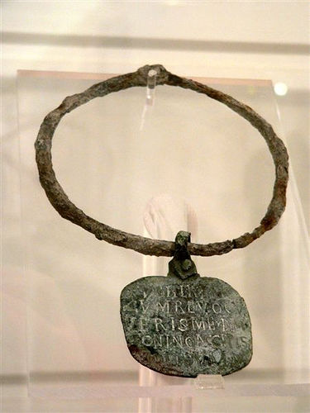
Roman Era Slave Collar

Slavery Before the 21st Century – A World-Wide Phenomenon
During antiquity, slavery flourished in Rome and Greece. It is estimated that one third of the population of ancient Greece were slaves. In Rome, approximately 30% of the people were slaves. The economies of ancient Greece and Rome depended so heavily on slaves that they are called “slave societies”.
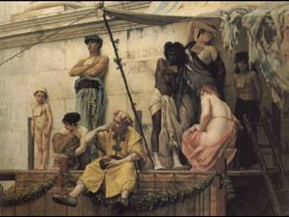
The Slavs are the largest single ethnic group in Europe, dominating Central and Eastern Europe. Slavic countries include Russia, Ukraine, Belarus, Poland, the Czech Republic, Slovakia, Serbia, Croatia, Slovenia, Macedonia, and Bulgaria. From antiquity through the 19th century, raiders would seize people from the Slavic countries and take them so far from their homes that they couldn’t find their way back. The raiders would then sell their captives as slaves. In fact, the origin of the word slave comes from the Muslims of medieval Spain who purchased so many Slavs from international slave traders that being a Slav became equated with being a slave. From Spain, the term spread to all of Europe.
The Slave Market, Gustave Boulanger, circa 1882
In the Middle Ages, people were held in bondage in countries such as France, Sweden, Germany, Russia, and England. The Domesday Book of the year 1086 was a tax roll and census compiled by the Norman conquerors of England. It shows that 20% of the people were enslaved in some English communities. Over the whole country, slaves accounted for 10% of the population. These slaves were almost exclusively white.
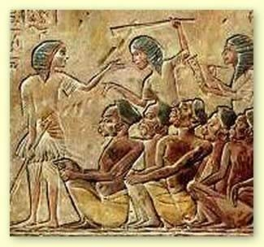
But slavery was not just a European phenomenon. Examples of other societies which employed slavery include: ancient Egypt, ancient Assyria, ancient Babylon, many African cultures, China, Persia, India, the Philippines, Nepal, Malaya, Indonesia, Japan, Central Asia, Arabia, and the Native American societies of the New World. Indeed, almost ¼ of the population in some Pacific Northwest tribes were slaves.
Egyptian Depiction of Slaves
Slavery flourished in all Islamic countries. The Ottoman Empire, centered in what is now Turkey, existed from the 14th to the 20th centuries, some 600 years. At the height of their empire, the Ottomans ruled all of Arabia, the Middle East, most of North Africa, and parts of South Central Europe. It was only in 1922 that the last Ottoman sultan was overthrown and the modern state of Turkey was established. At various times, slaves, primarily Slavs from Europe and blacks from Africa, manned the ships of the Ottoman Empire, served as its soldiers, held administrative posts in its government, generated much of its handicraft products, worked as domestic servants, and staffed its harems.
Slavery was practiced almost everywhere in sub-Saharan Africa. In some parts of Cameroon, Niger, and Angola, half the population consisted of slaves. Among the Yoruba of Nigeria and the Ashanti of Ghana, a third of the people in any village or city were slaves. Slavery in Africa took many forms including: chattel slavery, in which people could be bought and sold and in which their children were also slaves; debt bondage in which a person was forced to work to pay off a debt; and a condition similar to serfdom in Europe, in which people worked a specific piece of land, gave the fruit of their labor to the master, and could not leave the land.
African slave holders usually favored children who would grow up to be productive workers, or women who would produce more children and work in the fields. Children and women were also considered more docile than adult male captives who were more likely to flee or to resist their bondage. As a result, males captured in war or by African slavers were often killed outright. However, there were some African royal courts that, like the Ottoman Empire, used adult male slaves as administrators, skilled craftsmen, and soldiers.
“Pawnship” was an African form of debt bondage in which young girls were pledged as security for repayment of a debt. If the obligation was not paid, the girls were kept to work off the debt or to become slaves. The best opportunity for these young women was to marry into the family of their owner. This would cause the debt to be cancelled. Some African societies had a system called “clientage” which was similar to sharecropping. Landless people would work the owner’s land and divide the crop with the owner. This differs from slavery because the people who worked the land retained all of their rights as members of the community, while slaves have few, if any, rights.
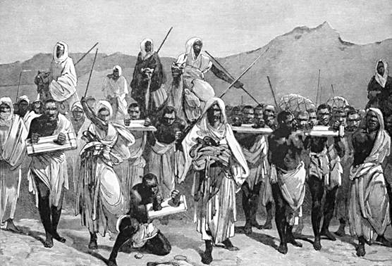
A Slave Caravan

Historically, the international trade in human beings has depended on the existence of “reservoir populations” from which slave traders could seize their victims. Two historic slave “reservoirs” have been identified and at least one other is suspected. The oldest consisted of the Slavs and Iranians who lived in provinces close to Europe. From antiquity to the 19th century, slavers would raid these populations. Another slave reservoir, existing from the beginning of the Christian Era to the mid-20th century, was the black populations of sub-Saharan Africa. A third possible population reservoir for slavers consisted of the Germanic, Celtic and other tribes who lived in Europe north of the Roman Empire. Over many hundred years, the Vikings would raid England, Germany, France and other territories in Europe, seize individuals and either use them as slaves or sell them at slave markets.
At some point in history, every major Western religion has condoned, slavery. Over three millennia, untold millions of Slavs were enslaved by Romans (pagan and Christian) and by Muslims. It is estimated by historians that between 650 and 1905, trans-Saharan Islamic slave traders and Indian Ocean slavers processed approximately 18,000,000 African slaves. The Middle Passage saw the transport of an estimated 6,000,000 enslaved Africans by Christians. Jews, after their release from bondage in Egypt were also involved, at times, in owning slaves and transporting them. Jews, along with Christians, owned slaves in the American South.

Slavery in the New World
Slavery was an important component of the colonization of the New World, whether by the British, the French, the Portuguese, or the Spanish. Slaves worked in the gold and silver mines in Spanish colonies in South America. The Portuguese used slaves in Brazil. The French imported slaves to Haiti. English tobacco and sugar plantations in the Caribbean and in the Southern colonies of North America relied on slave labor. Initially, efforts were made to enslave the indigenous peoples of the New World. But their death rates were very high. Blacks imported from the slave reservoir of sub-Saharan Africa proved a better investment. They worked harder and lived longer under the extreme conditions of New World slavery. Being an ocean away from their homes made them less likely to flee.

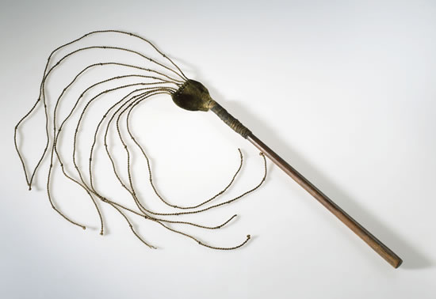

Cat O’ Nine Tails
Slave Collar

Slavery in the Americas existed from around 1619 to 1865. At first, colonists also used indentured servants. These were whites from Western Europe who had purchased their passage to the New World by agreeing to work for a period of four to seven years. Indentured servitude was a form of debt bondage, but it was time limited. Eventually, the colonists found that it was more profitable to own their slaves outright and import them from Africa.
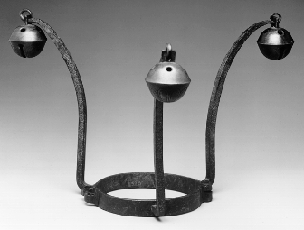
The focus on black slaves reinforced white racial prejudice against blacks. Many slaves in the ancient world had served their masters as physicians, educators, skilled artisans, and scholars. However, in the New World, it was a crime to teach a slave to read because it was thought that educated blacks would be more difficult to control. Only a few black slaves were allowed to learn a trade or acquire a skill.
Southern U.S. Slave Collar
Slavery in the New World was also different because it thrived in a highly competitive capitalist system in which slaves were used primarily for work on large plantations, raising labor intensive crops such as tobacco, sugar, coffee, cacao, or cotton. This often led to rigorous exploitation and harsh living conditions. It also meant that New World slavers preferred male slaves to perform hard labor in the fields.
It’s interesting to note that, initially, slavery in the New World had a complementary relationship with domestic African slavery. African slave owners preferred women and children as slaves. Before New World slavery created a demand for male captives, African slavers often simply killed their adult male captives. When the transatlantic slave trade began, African slavers could sell their adult male captives to the Europeans for transport to the New World.
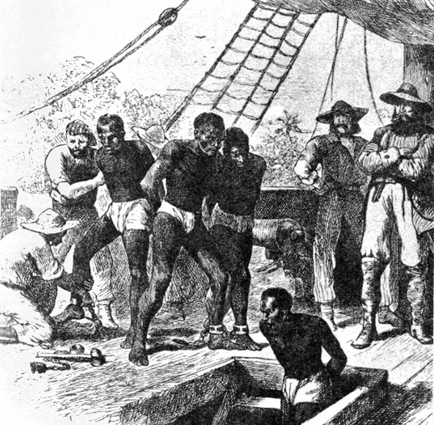
“Boarding” for the Middle Passage

Thus, for a time, New World slavery saved the lives of many African men. (This is one of the many ironic twists in the history of slavery.) However, before slaves arrived in the New World, they had to survive the horror of the Atlantic crossing in the fetid hold of a slave ship. Later, as the demand for male slaves in the New World increased, African slavers hunted for men. Although exact figures will never be known, estimates are that between six and eleven million Africans were transported across the Atlantic to slavery in the New World.
Despite the preference of American slave owners for male field hands, enough female Africans were transported to the Americas for the population of American born blacks to increase. In the U.S. alone, according to the 1790 Census, there were approximately 697,600 slaves. By 1860, the slave population had exploded to nearly 4 million people.
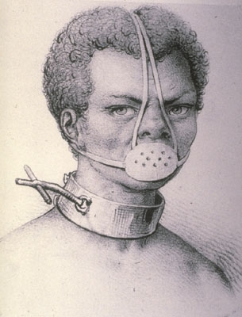
Slavery in the New World, as elsewhere, inflicted tremendous hardships on people. They were ripped from their families and their villages. They were denied their cultural heritage. They were forced to endure a horrendous trip to a place far from home. Slaves were required to toil long hours and their living conditions were often terrible. They were almost always denied self-fulfillment. When slave families became established in the New World, many children were sold to distant plantations. Over a third of the children born to slaves grew up without one of their parents and 20% of adult slaves never married. In a slave marriage in the United States, the vow was not the traditional “until death do us part”. In recognition that slave marriages were subject to the whims of the master, phrases such as "till death or distance do you part" were used instead.
Slave Collar and Muzzle (Brazil)
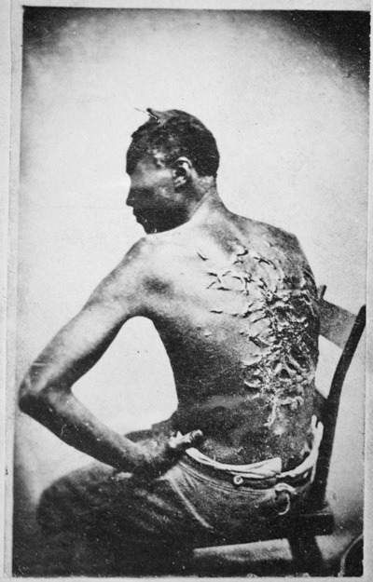
The murder of slaves by their masters and overseers was restrained because slaves were valuable property. However, the sexual abuse of female slaves was rampant. Many became impregnated by their white overlords. As a result, few modern-day black Americans are without white ancestors. In fact, many have more white ancestors than African ancestors. They are considered black only because, during slavery and the times of segregation, white society applied the “one drop rule”, treating people with any black ancestors as something less than white. It is another irony of history that although prejudiced whites considered themselves racially superior to blacks, they believed that the genes of the allegedly inferior race were so strong that a few of those genes could overcome the genes of the race that claimed superiority.

The World-Wide Attempt to Abolish Slavery
The abolition of slavery in a society usually comes from economic forces or through social reform movements. Often it is a combination of both. Sometimes, as in India and parts of Africa, the end of slavery was imposed by the military force of a conquering power.
Scars from Being Whipped
By the 1750s, substantial numbers of Europeans and Americans in the Northern colonies realized that slavery was wrong. This sentiment gained strong support in the United Kingdom (Great Britain), which officially outlawed slavery within its borders in 1772. However slavery was allowed to continue in the colonies of the British Empire, including parts of Canada, until it was outlawed by the British Parliament in 1834.
The expansion of colonial empires during the 19th century helped ensure the decline of slavery in Africa, East Asia, and Southeast Asia. Britain, with its powerful navy and armed forces, took a leading role in suppressing the slave trade and abolishing slavery. In fact, some African kingdoms that later became colonies were first invaded by British armed forces for the purpose of suppressing the slave trade. Other European colonial nations abolished slavery throughout their empires during the 19th century. It is yet another irony of history that colonialism, which brought so much oppression to the colonized peoples, also resulted in freedom for many slaves. However, some colonial powers required forced labor from local populations. The most glaring exception to the role played by colonialism in reducing outright slavery was the Belgian Congo, which was operated as one gigantic slave labor camp.
While colonialism was a factor in the decline of slavery, the creation of the United States, the first modern constitutional democracy, helped to preserve slavery in North America. In the 1770s, the Southern colonists foresaw that Britain would eventually abolish slavery in its Empire. However, if the American colonies broke away from Britain, they would govern themselves and could retain their “peculiar institution”. Many Northern colonists (but not a majority) opposed slavery. However, the Northern colonies knew that they could not stand alone against Great Britain, which was the most powerful Empire on earth. As a result, a bargain was struck. The Northern colonies would agree not to interfere with slavery in the South and the Southern colonies would join the American Revolution. During the Revolutionary War, the bargain was consecrated by the blood of Southern patriots who died and were injured in the cause of the Revolution.
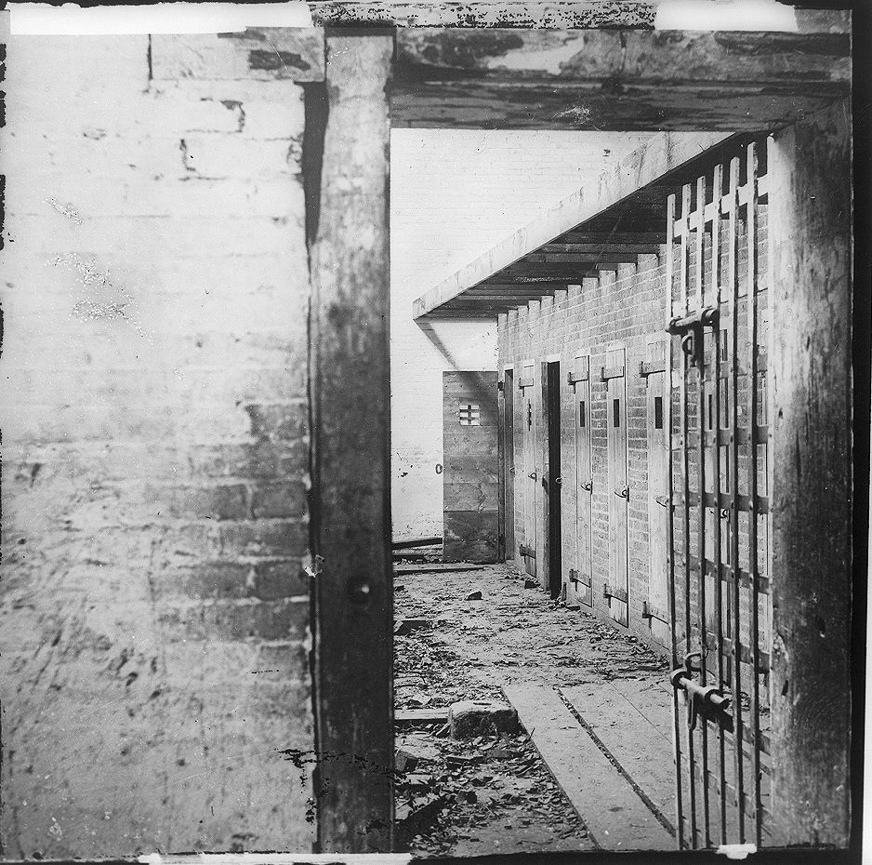
Slave Pen (Virginia)

Reflecting this bargain, the U.S. Constitution, the first modern law that protects the freedom of ordinary men in society, did not ban slavery, but instead, implicitly recognized it. The reference to “all other persons” in Article I, Section 2, is a reference to slaves. Congress was specifically prohibited from prohibiting the slave trade until 1808. (Article 1, Section 9, Clause 1.) It was only in 1865, after the bloodiest war in American history, that slavery was abolished with the passage of the Thirteenth Amendment.
The role of slavery in the creation of the United States, for centuries seen as a beacon of freedom and democracy the world over, is the most surprising irony in the history of slavery.
Throughout the 19th century, the legal protections enjoyed by slave masters were abolished in country after country. However, legalized slavery in some countries lasted into the 20th century. For example, slavery was not abolished in China until 1910. Legalized slavery persisted in Africa and much of the Islamic world through the First World War (1913 – 1917). Slavery was not ended in the African countries of Liberia and Ethiopia until the 1930s. (It is yet another irony that Liberia, a country established as a place to send liberated American slaves, clung to legalized slavery for so long.) The last nation to abolish all legal protections for slavery was Saudi Arabia, which did not take this step until 1962.
There are now several international treaties which forbid slavery. These include: the Slavery Convention, Geneva, 1926, the Universal Declaration of Human Rights, and the Supplementary Convention on the Abolition of Slavery, the Slave Trade, and Institutions and Practices Similar to Slavery . However, for slavery to be made illegal in any country, the laws of that country must be changed. The League of Nations and later the United Nations have been active in attempts to get their member countries to pass and enforce laws prohibiting slavery.

Slavery Underground and By Other Names – The Situation Today
The contemporary world is by no means free of slavery. It continues without any legal basis and often goes by other names. Modern day slavery includes bonded labor, debt slavery, child labor (including the sale of children to serve as workers), forced marriage, and sexual slavery. The International Labor Organization (ILO) estimates that there were 12.3 million slaves in the world as of 2007. Free the Slaves, an advocacy organization with a plan to end world slavery in 25 years, estimates the number at 27 million.
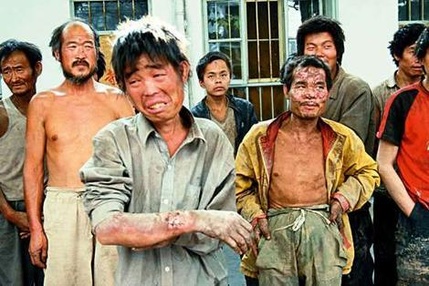
Modern Day Slaves (China)

Human trafficking is taking people from their home country to another country for the purpose of having them work in a condition amounting to slavery. The U.S. Department of State estimates that 800,000 people were trafficked in the international slave trade during 2007. In the U.S., the new slaves include:
Garment workers crammed in crowded rooms with little ventilation and hidden behind covered windows and barbed wire fences, girls held against their will and forced into prostitution, domestic servants compelled to do around-the-clock household chores, welders held in slave-like conditions in rooms with no gas or electricity – all without freedom to leave.

Free the Slaves identifies three trends which contribute to modern slavery:
- “a recent population explosion has tripled the number of people in the world, with most growth taking place in the developing world”;
- “rapid social and economic change 0have displaced many to urban centers and their outskirts, where people have no ‘safety net’ and no job security”; and
- “government corruption around the world, [that] allows slavery to go unpunished, even though it is illegal everywhere”.

Anti-Slavery International names Pakistan, India and Nepal as the countries with the greatest number of slaves. The continent with the most slaves is Asia. Free The Slaves estimates that approximately 14,500 slaves are illegally brought into the U.S. each year.
Child labor is also a serious problem around the world. The ILO estimates that 122.3 million children work in the Asia-Pacific region, 49.3 million in sub-Saharan Africa, and 5.7 million in Latin America and the Caribbean. These children labor for 12 hours a day or more and they are prevented from going to school. Their working conditions, like many adult workers in their societies, are usually dangerous and unhealthy. Child labor is similar to slavery because the children have no real choice about whether they want to work or not. Their wages often are paid to their parents.
An institution that has survived into modern times and which bears a strong resemblance to slavery is the forced marriage of girls. These “arranged marriages” are a time-honored custom in many societies and the families who arrange the marriages do not believe they are depriving their female children of important rights. However, the girls have no say in who they are going to live with for the rest of their lives. In many of these societies, a woman has no right to obtain a divorce if she is dissatisfied with her marriage. Instead, she must submit to this stranger, bear his children, and perform domestic labor in his home.
Even closer to slavery is “compensation marriage”, an ancient custom of forcing girls into arranged marriages to compensate another family for a murder perpetrated by a male relative, to offset debts, or to settle other inter-clan or family disputes. Compensation marriage is prevalent in Pakistan’s Northwest Frontier Province, Afghanistan, and parts of the Middle East. The United Nations and other multi-national organizations are now trying to eradicate this violation of human rights.
In addition to its efforts to enforce the legal ban on slavery, the United Nations has also moved to expand the definition of slavery to other forms of the coercive use of human beings. The United Nations now contends that, in addition to child labor, forced marriage, and compensation marriage, practices such as child prostitution, child pornography, sexual mutilation of female children, the use of children in armed conflicts, and the forced donation of organs of the body are also forms of slavery.

Conclusion:
Throughout history and among all peoples, slavery has left a trail of untold misery and lost opportunity for a fulfilled life. While legal slavery has been abolished, outright slavery or coercive practices that are similar to slavery are protected by custom or corruption. They blight millions of lives the world over.

James Frieden – 2008

ENDNOTES: ? "slavery." Encyclopædia Britannica. 2008. Encyclopædia Britannica Online. 15 Jan. 2008 <http://www.britannica.com/eb/article-9109538>. (hereinafter “Britannica Slavery Article”) "Saqalibah." Encyclopædia Britannica. 2008. Encyclopædia Britannica Online. 15 Jan. 2008 <http://www.britannica.com/eb/article-9065714>. The American Heritage College Dictionary (1997) Boston Houghton, Mifflin, Company – definition of slave
Britannica Slavery Article.
Britannica Slavery Article.
Britannica Slavery Article and "Ottoman Empire." Encyclopædia Britannica. 2008. Encyclopædia Britannica Online. 15 Jan. 2008 <http://www.britannica.com/eb/article-9111081>.
Britannica Slavery Article, page 2.
Britannica Slavery Article, pp. 2 & 3.
“Slavery in Africa”, Digital History, University of Houston et al <http://www.digitalhistory.uh.edu/database/article_display.cfm?HHID=64>, accessed January, 28, 2008 and “Slavery in Africa” by Alistair Boddy-Evans, from About.com; January 6, 2008, <http://africanhistory.about.com/od/slavery/p/SlaveryTypes.htm>
Britannica Slavery Article, page 5.
Britannica Slavery Article, page 2; Others put the estimate at between 9.4 and 14 million. See “Quick guide: The slave trade,” BBC, 15 Jan 2008 < http://news.bbc.co.uk/1/hi/world/africa/6445941.stm>
“Quick guide: The slave trade,” BBC, 15 Jan 2008 < http://news.bbc.co.uk/1/hi/world/africa/6445941.stm> “The Story of African Slavery” BBC World Service <http://www.bbc.co.uk/worldservice/africa/features/storyofafrica/9chapter5.shtml > accessed January 29, 2008
Britannica Slavery Article, page 2.
See references at note ix.
United States Census – Race and Hispanic Origin: 1790 to 1990, U.S. Census Bureau
“African American Voices - Slave Family Life”, Digital History, University of Houston and other institutions,< http://www.digitalhistory.uh.edu/black_voices/voices_display.cfm?id=22> accessed January 28, 2008.
Who is Black? One Nation’s Definition by F. James Davis, published by PBS and attached to the web page for “Jefferson’s Blood”, accessed February 24, 2008. <http://www.pbs.org/wgbh/pages/frontline/shows/jefferson/mixed/onedrop.html>
“Slavery in Africa” by Alistair Boddy-Evans, from About.com; January 6, 2008, <http://africanhistory.about.com/od/slavery/p/SlaveryTypes.htm>
“What is Modern Slavery” from Anti-Slavery International, <http://www.antislavery.org/homepage/antislavery/modern.htm> accessedJanuary 6, 2008; “Slavery Today” by Free the Slaves. <http://www.freetheslaves.net/NETCOMMUNITY/Page.aspx?pid=301&srcid=348> Accessed, January 6, 2008; and “Forced Labor Said to Bind 12.3 Million People Around the World”, by Steven Greenhouse, New York Times, May 12, 2005 <http://www.nytimes.com/2005/05/12/international/12labor.html?_r=3&oref=slogin&oref=slogin&oref=slogin>
Human Trafficking in California, Final Report of the California Alliance to Combat Trafficking and Slavery Task Force -- <http://www.safestate.org/documents/HT_Final_Report_ADA.pdf>
Ibid.
See cites at Note XV.
The Practice of “Compensation Marriages a report by the United Nations Population Fund.
“Fact Sheet No.14, Contemporary Forms of Slavery”, Office of the High Commissioner for Human Rights, < http://www.unhchr.ch/html/menu6/2/fs14.htm> accessed January 28, 2008.

