Diagrams of Fatty Acids that Relate to the Movie Lorenzo’s Oil

Cerotic Acid (C26:0) This is one of the VLCSFAs implicated in ALD
H
C
O
O
H
H
H
H
H
C
C
H
H
H
H
C
C
H
H
H
H
C
C
H
H
H
H
C
C
H
H
H
H
C
C
H
H
H
H
C
C
H
H
H
H
C
C
H
H
H
H
C
C
H
H
H
H
C
C
H
H
H
H
C
C
H
H
H
H
C
C
H
H
H
H
C
C
H
H
H
H
C
C

H
H
H
H
H
C
C
H
H
H
H
C
C
H
H
H
H
C
C
H
H
H
HH
C
C
H
H
H
H
C
C
H
H
H
H
C
C
H
H
H
H
C
C
H
H
H
H
C
C
H
H
H
H
C
C
H
H
H
H
C
C
H
H
H
H
C
C
H
H
H
H
C
C
C
O
O
H
Lignoceric Acid (C24:0) This is one of the VLCSFAs implicated in ALD

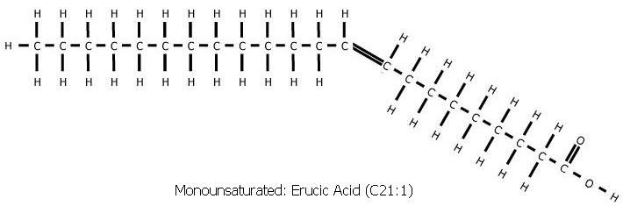

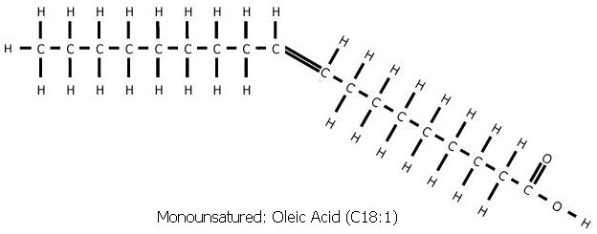

Diagram from TeachwithMovies.com Learning Guide to Lorenzo’s Oil

© TeachWithMovies.com Licensed pursuant to http://www.teachwithmovies.org/terms-of-use.html

