Codependence -- What Happens When a Family Member is an Alcoholic or a Drug Addict

Enablers in Chief, Family Heroes,
Scapegoats, Lost Children and Mascots

Introduction: Let’s say your class has 30 students in it. Look around. The statistics tell us that six or seven of your classmates, before they reach the age of 18, will have experienced the alcoholism or drug addiction of a family member. Pick any five kids in your school at random, or how about your friends? You’ll be lucky if one or two of them haven’t had an alcoholic or drug addicted parent, brother or sister. If you are one of the students whose family has been affected by alcoholism or drug addiction, you should know that there are many others a similar situation.
When one member of a family is an alcholic or addict, everyone in the family suffers. Alcholic/addict parents can’t give consistent nurturing love to children. Family members become so concerned with the problems of the alcoholic/addict that they ignore their own needs and those of other family members. Living with a substance abuser can lead to “enabling behaviors” and a psychological condition called “codependence”. These can interfere with a child’s normal growth and development.
This handout will describe some of what psychologists have discovered about what happens in the families of alcoholics/addicts.
What are Enabling Behaviors? No one wants to see a family member suffer. So, naturally, relatives of an alcoholic/addict will want to help their loved one avoid the problems caused by an intoxicated lifestyle. This extends from simple things, like taking on extra chores within the family or lying to give a legitimate reason for missing work, to sophisticated behavioral patterns that excuse the substance abuse and, in so doing, encourage it.
For alcoholics or drug addicts, admitting that they have a serious illness and giving up intoxication involves wrenching changes. They have to develop a new view of themselves, change how they relate to others, face challenges and problems without the crutch of being high, stop doing something that gives them pleasure, and endure the pain of withdrawal. Fighting alcoholism or drug addiction is hard and people won’t do it unless they experience the pain that an intoxicated life causes and can foresee the loss of everything they hold dear -- unless they stop drinking or using.
Thus, while family members think they are helping when they protect a loved one from the consequences of intoxication, in fact they are making it easier for the alcoholic/addict to live an intoxicated life. They are enabling the continuation of the alcoholism or drug addiction. Enabling behavior is a natural response to the abnormal situation of having an alcoholic/addict in the family. Moreover, substance abusers are experts in talking family members into helping them out.
Many substance abusers are so committed to intoxication that they steal from family members, sell family possessions, or take money set aside to pay important bills and spend it on alcohol or drugs. Some families tolerate this behavior, even while sincerely claiming that they object to it. Other families seek to limit the harm the substance abuser can cause. Many families close their eyes and deny that the substance abuser has any problem at all. Other families realize that the alcoholic/addict is in trouble, but don’t believe that any treatment or self-help program like Alcoholics Anonymous (AA) will work. Others move heaven and earth to get the substance abuser into treatment or to attend AA meetings and fall back on enabling behavior if these efforts fail. While every situation is different in many respects, it’s always true that every action which protects the substance abuser from the consequences of being intoxicated helps him or her continue the addictive behavior.

Codependence in Families of Substance Abusers: People who are psychologically healthy try to live a life that nurtures others, satisfies their own needs, and allows them to fulfill their aspirations. We can call this “self-actualization”.
A healthy family is an association of two or more persons who exchange love and affection and who provide support as needed. There are many different roles that a person can take in a family. Some roles require a family member to help another become self-actualized. The primary examples of this are parents, who are responisble for nurturing and supporting their children. On the other hand, children are not responsible for nurturing the parents and helping the parents become self-actualized. Their responsibility is to grow into mature and caring adults. In healthy families, spouses care for each other and help each other fulfill their aspirations.
These relationships change over time. As a child matures and becomes independent, the parent is no longer responsible for helping the child attain a self-actualized life. When the parent becomes elderly and reaches the end of life, the role of the child can become that of the nurturing caretaker. In all families, accommodating the needs of the various members in their changing situations involves adjustment, communication and, sometimes, negotiation.

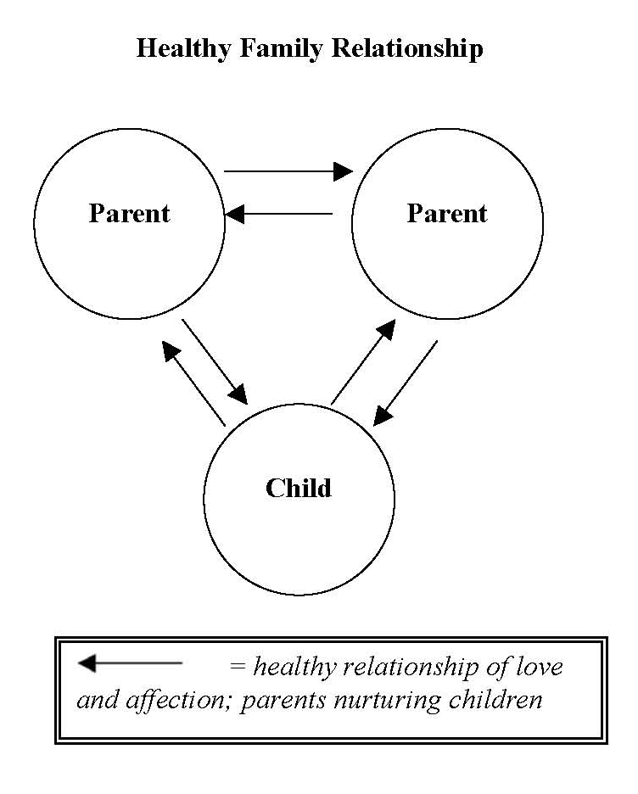
People who are frequently intoxicated cannot fulfill their normal roles in a family, especially when the substance abusers are parents. Children need consistent nurturing to develop a healthy psychological makeup. Substance abusing parents are often emotionally absent. There will be times when the lure of getting high prevails over fulfilling responsibilities to children. When alcoholic/addict parents are high or feeling hungover, they can act irrationally, scream at their children, or hit them. In addition, adult substance abusers may require care from their children when the children are still young and the adult should be caring for them. Moreover, substance abusing parents are more likely than other parents to sexually abuse children.
Alcoholics/addicts are frequently unsupportive spouses. This, too, has an impact on children since they must watch as the non-addicted parent tries to cope with the substance abuse. Often, substance abusers adopt the role of being chronically sick people in need of frequent care. Sometimes, families must also cope with the failure of the substance abuser to provide financial suport.
When a substance abuser’s insult to the family system continues over a long period of time, the abnormal situation begins to seem normal. When this occurs, family members will find new roles in an altered and dysfunctional system of family relationships. Children may take on the role of trying to solve the adults’ problems. Other children may abandon all hope of being nurtured by a parent and simply withdraw. Some children may exist in a state of confusion and become unable to develop trusting relationships. Still other children rebel and reject the family altogether. Spouses may devote their lives to caring for the “sick person of the family” who needs help only because of substance abuse.
People need psychological satisfaction in whatever lives they lead. Over months and years, members of families with an alcoholic or addict will learn to get psychological satisfaction out of their new roles. Since they are deprived of normal relationships, especially in relation to the alcoholic/addict, family members will begin to rely upon and actively seek the psychological gain that they get from their new roles. However, to the extent that these new roles abandon life-goals in order to take care of the substance abuser or are adjustments to a life of reduced emotional support and inadequae nurturing, these roles can cause psychological injury and be detrimental to self-actualization. When this occurs, a psychologist looking at the family would come to a diagnosis of codependence.
Let’s see how this plays out in a hypothetical family.
A typical scenario of alcoholism and codependence: Emily and Joseph are a young couple in their late twenties. They are married, happy and have two children whom they adore. Both have interesting jobs. Joseph is an up and coming middle level executive for a computer company and Emily is a school psychologist. They’ve found a good babysitter/housekeeper to take care of the children during the day. They almost always have fun when they go out together. Emily is the life of the party when she’s had a few drinks.
However, Emily is an alcoholic. When she drinks too much at night, Joseph takes care of her and helps with the kids in the morning. When Emily stays out until after dinner, drinking with her girlfriends from work, Joseph cooks and takes care of the kids. Over the years, although Joseph has felt frustrated at times, he has begun to cherish his role of taking care of Emily. He is Mr. Fix-it, the “go to” man in the family. Putting Emily back together is an important way in which he shows his love for her. Joseph is close to his children, closer than many fathers, because he sometimes substitutes for their mother.
Joseph knows that Emily has had frustrations and disappointments in her life. He reasons that the drinking helps her cope. Certainly, that’s what Emily says. And on many days, perhaps most days, Emily is a great wife and mother. Those are the days that Emily can control her drinking. Because Emily frequently hides her alcohol consumption and is still able to function on most days and because Joseph doesn’t want to believe that his wife has a problem, he doesn’t realize that his wife is a substance abuser.
Joseph is sometimes distracted at work, worrying about Emily and the kids. When Emily has a hangover or cannot take care of the kids, Joseph gets to work a little late or will leave work early. Sometimes when Emily’s hangover is really bad, he has to call in sick himself so that he can take care of her and see to the children.
The oldest child, Jennifer, age 8, tries behave perfectly in order to help Dad and, so that when Mom is really crabby in the morning (and sometimes in the evening, too), Mom will feel better because Jennifer is the best child anyone could imagine. Jennifer doesn’t think about what she might want. Her concerns are her father and her mother, and her little sister Sasha.
Sasha, age 5, is feeling very confused. She doesn’t understand why her mother can be a great mother one day, giving Sasha all the love and affection Sasha sees other mothers give their children, but on the next day, for no reason, her mother is distant or even hostile. Sasha’s father and older sister try to make up for Emily’s erratic behavior. But this can’t make up for an inconsistent mother. Sasha has begun to withdraw from Emily and nurse her own hurt and pain in private.

Codependent Roles in Families of Substance Abusers: While each family has its own distinct system of relationships, psychologists have identified several dysfunctional codependent roles that are adopted by members of families that include an active alcoholic/addict. Understanding these roles will help us visualize what occurs in codependent families.
THE ENABLER IN CHIEF: This is the person who takes primary responsibility for protecting the alcoholic/addict from the consequences of intoxicated or out-of-control behavior. The Enabler in Chief organizes the family’s efforts to protect the substance abuser and tries to ensure that other family members cooperate. Usually an Enabler in Chief is a spouse or a parent, but, most tragically, this role also can be taken by a child. In our scenario, Joseph is the Enabler in Chief. His codependent enabling behavior is starting to cost him at work and trouble is brewing with the children.

The Scenario Continues: Emily is so good at her job and her employer is so understanding, that she can have a few drinks at lunch and not get fired. However, she is drunk just about every evening and has a hangover most mornings. She is having increasing difficulty in dealing with the kids. In fact, evenings and mornings at home have become pretty much Joseph’s responsibility. It is Joseph who arranges doctors appointments and playdates for the children. Joseph (assisted by Jennifer) makes dinner, cleans up, and manages the babysitter/housekeeper. Joseph tries to pay attention to Sasha, but usually there just isn’t enough time. The occasions that Emily comes home late after talking to her girlfriends at the bar near work increase. Joseph is the center of the family and he loves his role.
However, this is all taking a mounting toll on Joseph’s job. He is increasingly late to work or has to leave early to take the kids to one place or another. Sometimes, after she’s had a few drinks at lunch and feels bad about the frustrations of her life, Emily will call Joseph at work and talk to him for an hour. Joseph is surprised when he is passed over for a promotion that he expected to get.
In this family, Jennifer is the shining glory. She makes straight As, never misbehaves, and helps out with Sasha. The two sisters are very close. Joseph often wonders what he would do without Jennifer.
Emily isn’t always a drain on the family. There are times when she comes through for the kids or for Joseph, although this happens less than it did in the past. She and Joseph are still in love and they still have fun together.

THE ENABLER IN CHIEF, continued: Pscyhologists describe codependence as an inability to separate the codependent’s life from the life of the substance abuser. In our scenario, Joseph is doing just that, allowing Emily to abandon her role in the family while he gets psychological satisfaction from taking it on himself. He’s doing a great job of protecting Emily from realizing how truly ill she is. While Joseph is adapting to the abnormal situation in which he finds himself, a better way to adapt, better for him, for the children, and for Emily, would be to insist that Emily stop drinking and, if necessary, go into a treatment center.
In more serious cases of codependence, Enablers in Chief give up almost completely on their own life goals and live primarily for the psychological satisfaction that comes from helping the alcholic/addict. As psychologists put it, codependents lose clearly defined ego boundaries and are unable to detect where other people end and the self begins.
THE FAMILY HERO: Another role that sacrifices personal goals for the sake of the alcoholic/addict is that of the Family Hero, a family member who tries to act perfectly and do everything right. When the Enabler in Chief and the substance abuser are married, the Family Hero is often the oldest child. (Obviously, this is Jennifer in our scenario.) A child Family Hero makes good grades, seldom gets into trouble, and almost never does anything to cause the non-addicted parent (the Enabler in Chief) pain or distress. Often plagued by guilt and shame, the child Family Hero thinks that if only he or she were perfect, the addicted parent would reject intoxication and become the parent the Family Hero always wanted (and deserved). A child Family Hero cannot speak up for his or her own needs or desires and is motivated by fear of further disruptions in the family system.
In a two parent family seriously impacted by alcoholism or drug addiction, perhaps the most important person that a child Family Hero tries to please is the Enabler in Chief. A fully codependent spouse can be a pitiful sight, having sacrificed much of his or her life for a substance abuser who cannot return a true and mature love. The fundamental allegiance of any alcoholic/addict is to intoxication; any love he or she can provide is limited. The child Family Hero incorrectly believes that perfect behavior will make up for losses in the life of the Enabler in Chief. But no child can fully substitute for a spouse. The roles are completely different.
The fundamental problem with the role of the child Family Hero is that the child acts perfectly for the benefit of others, rather than for the purpose of self-actualization. Some Family Heroes who are fully involved in codependence don’t know what they want for themselves. Moreover, Family Heroes, the Jennifers of this world, are bound to be frustrated because an alcoholic/addict will not stop drinking or using just because a child behaves perfectly. Nor will having a perfect child make up for the sacrifices and losses of a parent Enabler in Chief. The only way to be a true Family Hero is to stop the codependent behaviors and take the route of self-actualization.
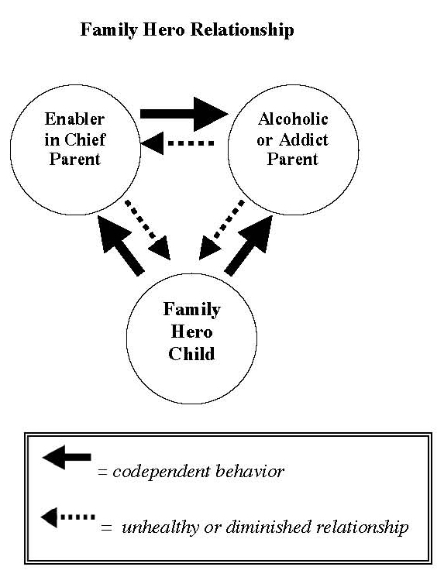
THE LOST CHILD: To avoid causing problems and to help the family system maintain a balance, some children avoid getting in the way and give up any effort to get their own needs met. An alcoholic/addict parent will be absorbed with getting high and avoiding the consequences of the intoxicated life. A parent Enabler in Chief might be so focused on protecting the substance abuser that he or she will not have time or energy to nurture this child. The Lost Child understands, usually subconsciously, that insisting on attention will add to the burdens of the stressed out Enabler in Chief and probably provoke an indifferent or hostile reaction from a substance abuser focused on satisfying the need for intoxication. If a child cannot become the Family Hero, due to his or her young age or for other reasons, one route is to withdraw and make no demand for love and affection. In effect, the Lost Child disappears from the emotional life of the family.
A Lost Child will often have terrible problems with self-esteem and in developing healthy relationships with others. A Lost Child flees from conflict and does not feel loved by other members of the family, most tragically, by his or her parents. The Lost Child is motivated by fear and an absence of self-respect. A Lost Child often feels guilt, loneliness, neglect, and anger. In our scenario, Sasha has aspects of the Lost Child, but her situation is helped by the fact that Joseph is not fully involved in codependence and spends some time with her. Most importantly, her older sister is a major factor in her life.

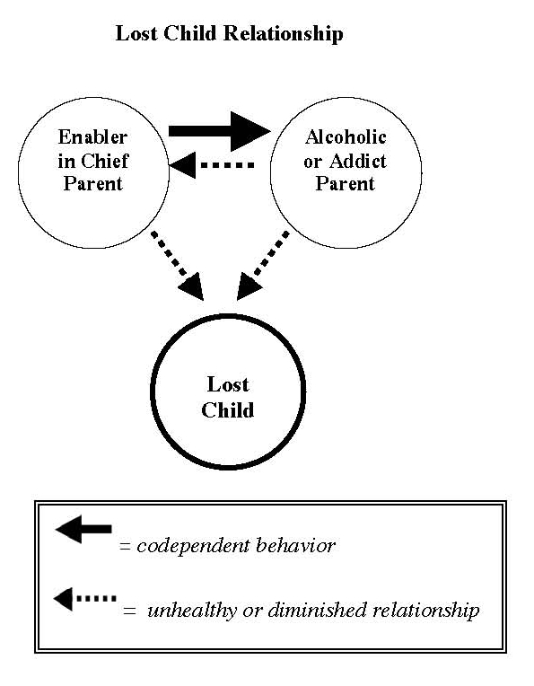

A Different End to the Scenario: As we left our story, Emily was on a downward spiral and would soon be unable to function at all. However, many alcoholics or addicts can continue to function fairly well for years, and even decades. If Emily had continued being able to be a good wife and mother on most days and avoided the quick downward spiral, the ending would have been better for Joseph. As a successful Enabler in Chief, he would continue to enjoy being Mr. Fix-it but since Emily was functional most of the time, he might also have been able to get that promotion and progress at his job.
The worst injury in this scenario would be to the children. Jennifer would grow up a perfect child always seeking to attain the impossible goal of pleasing Emily into being a better mother and making up to her father for the effects of Emily’s drinking. Jennifer would be a success in almost everything she tried to do, but it would be a hollow success because it would not get her the mother she had always wanted or make her father completely happy.
Sasha would continue to be confused about her mother’s love, a condition which often results in years of dysfunctional relationships and the need for psychological therapy.
OTHER ROLES:
THE BAD SEED: This is the child who believes that he or she is doomed, by genetics or otherwise, to repeat the lost life of the substance abuser. This child has negative self-esteem and sees no way out.
THE SCAPEGOAT: Another dysfunctional role in families with alcoholics is the Scapegoat. Scapegoating occurs when one family member is blamed for another family member’s substance abuse or for other problems in the family caused by the substance abuse. Blaming the Scapegoat diverts attention from the problems caused by the alcoholic/addict. Often Scapegoats are told that they “can’t do anything right.” This erodes the Scapegoat’s self-esteem and often breeds resentment. Scapegoats have a tendency to rebel (and rightly so) or to become drug users themselves.
THE MASCOT: Everyone needs some comic relief and in dysfunctional families this is supplied by the Mascot. This person, usually a child, entertains the family and makes everyone laugh. However, Mascots do not feel loved for themselves and, like all codependent children, they have a hard time growing out of the role as adults. The underlying feelings of a Mascot are primarily embarrassment, shame, and anger.
COMPLEXITY IN FAMILY SYSTEMS: Family situations are very complex and the roles and positions of the various family members will change over time and in response to different situations. People will take on the roles in varying degrees. Some are only lightly impacted, while others can be heavily involved. One person can take on two or more roles. The degrees of codependence can change with different circumstances and events. Some situations, like the arrest of the alcoholic/addict for drunk driving, can make people realize the futility of codependence and the need to confront the problem. Others, such as an unsuccessful attempt to get the substance abuser into treatment, can cause a relapse back into codependence. However, the roles described above have served for years as a helpful way to begin an analysis of dysfunctional family relationships when one member of the family is a substance abuser.

What Causes Codependence? At least five active forces or underlying conditions help trigger codependent behavior. Understanding them will help people avoid being caught in the codependence trap.
The first, as we have discussed, is the love and caring that the family members naturally feel for the alcoholic/addict.
The second active force is the alcoholic/addict him or herself. Substance abusers are experts at convincing family members to help them avoid the consequences of their addiction. They will use any trick, any lie, and any appeal to sympathy.
Shame is a common feeling in the families of alcoholics/addicts. This often prevents family members from facing the problem, seeking help, and maintining personal boundaries between themselves and the substance abuser. This is a third factor contribuing to codependence.
Some codependent family members have a psychological predisposition to codependence; this is the fourth cause. Adults could have experienced codependent behaviors in the families that raised them. Thus, the scripts of codependence seem normal and they reenact them with their own families. There could also be other psychological factors that predispose people for codependence. Some have contended that women who are trained to nurture and to sacrifice their interests for others are predisposed to codependence.
The fifth force triggering codependent behavior is the need of family members for consistent love and nurturing from parents who are substance abusers or distracted, overwhelmed Enablers in Chief. This applies most clearly to the roles of Family Hero, Lost Child, and Mascot.

Is Codependence Inevitable? The short answer is “no”. There are several solutions for families with an alcoholic/addict. The best is to get the substance abuser into treatment, AA, or some other self-help program that will free him or her from the addiction. If that doesn’t work, family members can get support from psychologists or from self-help groups such as Al-non or Alateen. The key is to stop enabling, something much easier said than done.
In extreme situations, spouses may have separate or divorce and children may have to distance themselves from their families, or at least from the alcoholic/addict. One scenario for a male child in a family with a substance abusing father who beats the mother and children is for the child to make a conscious decision to “go the other way” and never drink to excess or hit a child or a woman. This child keeps his own self-respect and his love for his mother and siblings. He loses only the relationship with the substance abuser.

When the Alcoholic/Addict Enters Recovery: The psychological satisfaction from codependent behaviors that family members have come to rely upon make these behaviors difficult to give up. Often, when alcoholics and addicts stop using intoxicants and start to assume a more equal and competent role in the family, other family members still relate to them in codependent ways. However, a substance abuser in recovery no longer wants to be treated as a sick person who needs protection from the consequences of his or her actions. In fact, part of the recovery process is taking responsibility for one’s own actions and acting more responsibly. When a recovering alcoholic or drug addict will not accept the enabling behaviors that he or she had previously sought, difficult adjustments may have to be made, particularly with a spouse Enabler in Chief. Many marriages and romantic relationships can’t adjust to the recovery process and the couples separate or divorce.

A Note to Students: If anything you have read reminds you of behaviors in your family, you are not alone and help is available. Members of families with alcoholics/addicts are often ashamed of their home situation and mistakenly believe it to be so complex and difficult that no one can help. In fact, there are effective programs available to assist childen, teenagers and adults in dealing with codependence. If you can’t afford to pay for assistance, there may be subsidized or free clinics. Contact your teacher, school psychologist or a counselor. They will be able to help you.

This article written by James Frieden, TeachWithMovies.org, June 15, 2008
© TeachWithMovies.com Licensed pursuant to http://www.teachwithmovies.org/terms-of-use.html

