AVIAN MIGRATION

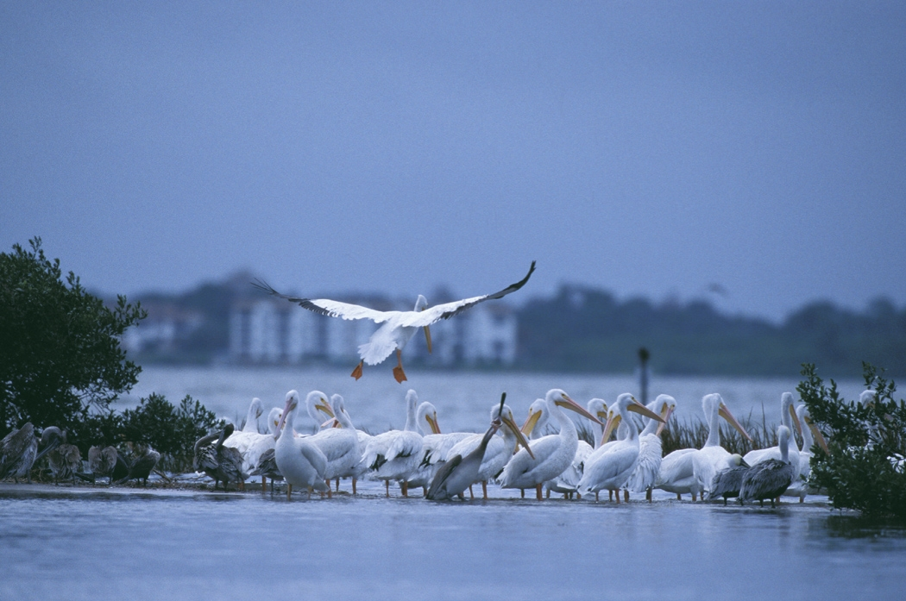
White Pelicans
Table of Contents

INTRODUCTION … pg. 3
- Biome Migration: Seeking Evolutionary Advantage Through More Food and Enhanced Reproduction …pg. 4
BIOME MIGRATION AMONG BIRDS … pg. 5
- The Basics of Bird Biome Migration … pg. 5
- Flyways and Funnels … pg. 11
- Bird Navigation … pg. 13
- Model for the Evolution of a Migratory Flock and a Migratory Species … pg. 15
- Reintroducing Migratory Behavior in the Eastern U.S. Whooping Crane Flock … pg. 18

Introduction
A biome is an area characterized by distinctive climate and soil conditions and a biological community adapted to those conditions. Examples include desert, grassland, tundra, rain forest, and coniferous forest.
The term "migration" can refer to the periodic movement of part or all of an animal species between biomes. Birds which nest in the far north during the summer and fly hundreds or thousands of miles to winter in the south are classic examples of animals that migrate between biomes.
Migration usually occurs in response to changes in the seasons (cold and warm, wet and dry) which generally affect food availability. Migration of animals from one biome to another is an important process in the natural world. For example, about 650 bird species nest in the United States. Approximately 520 of these species migrate south to spend the winter.
From an evolutionary standpoint, most migratory animals change biomes to reach locations in which food is more plentiful than in their home range or in which there are safer nesting grounds. A population that has access to more abundant food or safer nesting grounds will do better than a population that does not.
The word "migration" has a number of other meanings. To distinguish what we will be studying in this unit from other meanings of the word migration we will call it "biome migration".

Biome Migration: Seeking Evolutionary Advantage Through More Food and Enhanced Reproduction
Most animals migrate horizontally, moving over the surface of the earth toward areas in which there is a greater abundance of food. However, some migration is primarily vertical, as when fish move to different depths of water or when birds or land animals move from mountains to lower elevations in nearby foothills or valleys.
The periods of migration are usually annual but they can also be twice a year or they can extend over many years.
Biome migration is usually based upon cycles of surplus and scarcity which result from seasonal changes in temperature. Animals that are mobile move to areas in which food or water is plentiful and thereby obtain an evolutionary advantage. See Model for the Evolution of a Migratory Flock below. The classic example of migration is provided by birds with a north/south migratory pattern. In the summer the far north explodes with insect and plant life. In addition, there are fewer predators in this area than in more southerly climates. Plentiful food and fewer predators result in excellent breeding grounds for many types of birds. By the end of the summer, when food is getting scarce in the far north, the birds migrate south to their home ranges. In the spring they go north again to nest and feed.

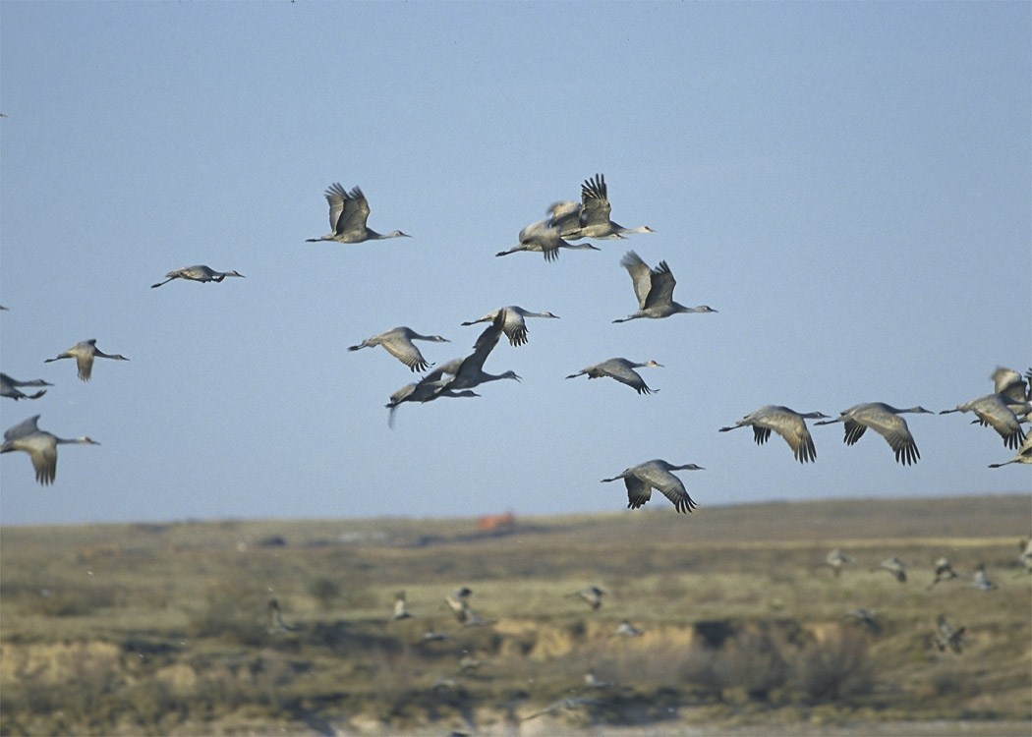
Sandhill Cranes
The Basics of Bird Biome Migration
The longest and most dramatic biome migrations are undertaken by birds. Birds are the most mobile animals. They are also among the most motivated to seek new sources of food because their high metabolic rate requires an abundant supply of energy. (The heart of a ruby-throated Hummingbird beats 500 times a minute).
All birds evolved from a common ancestor. In addition to high metabolism, birds have feathers, hollow bones, horny beaks, and large yolked hard shelled eggs. While some birds no longer fly, their ancestors did.
Birds are a "class" of animal species. You have probably already studied the taxonomy of animal species and they will be referred to several times in this handout. Birds are classified as:
Kingdom
Animalia
Phylum
Chordata
(animals with spinal cords)
Subphylum
Vertebrata
(animals with spinal cords contained within vertebrae)
Class
Aves
(birds)
Birds are on the same classification level as mammals, fishes, reptiles, and amphibians because, like birds, all these classes have spinal cords contained within vertebra. The classifications below subphylum are: "orders", "families", "genera", and finally "species". More on this later.

Variations on the basic themes of bird migration appear to be infinite. In many species some populations migrate and others do not. Within the same population of certain species, the migration can be partial. Some birds within the population will migrate while others will stay and reside in the home range year-round.
In some partially migrating populations, only the smaller juvenile birds will migrate while the adults stay put for the winter or the females migrate while the males stay put. For example, the chaffinch population in Britain does not migrate, while in Scandinavia the female chaffinch migrates but not the male. In some species, some individuals may winter in one area one year and the next year take another migration route and winter in another area. Some birds migrate in families. Some populations within the same species migrate at different times and along different routes. Some species migrate long distances without stopping, while others migrate in stages, taking breaks to rest and feed along the way. Most bird species migrate primarily north/south but there are others which migrate primarily east/west, often seeking the more moderate climate of the seacoast during the winter.
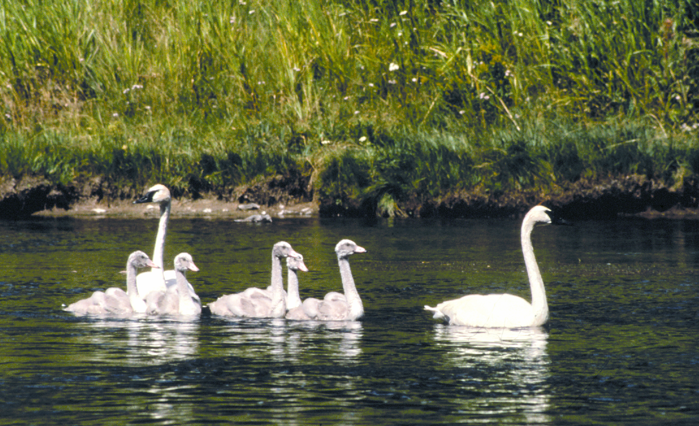
Swans migrate in families
National Park Serv.

Most species of birds migrate at night ("nocturnal" migrators) while some travel during the day ("diurnal migrators"). The reason that most birds migrate at night is that during the day the sun warms the earth which heats the air near the ground. As the hot air rises it creates disturbances in the air, making flying for birds who gain height by flapping their wings more difficult. In addition, the temperatures are cooler at night and predators less frequent. On the other hand, raptors, cranes, and storks, species which use thermal currents to gain altitude migrate during the day. They make good use of the very updrafts that make diurnal migration difficult for other birds. Some species of birds fly during the day because they need to eat insects that they can catch during the day. Examples are swallows, swifts and nighthawks.
Some species of birds journey during specific parts of the day, such as sunrise or sunset. Even within species, different populations will migrate at different times of the day. Certain species of birds are diurnal migrators at times and nocturnal migrators at other times.
Land birds that fly over oceans or seas will fly day and night until they reach land. Other birds, including raptors and storks, are limited to migration by flying over land where they can take advantage of thermal updrafts. Some raptors delay their migration so that they can feed their young the meat of other migrating birds.
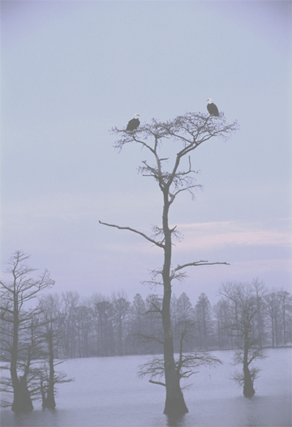
Bald Eagles - National Park Service
While the vast majority of birds move around by flying, some birds, such as the ostrich, Emu, and penguin walk or hop. Penguins and the Razorbill are most at home swimming.
Feathers and hollow bones are the primary adaptive techniques allowing birds to fly. Feathers are flexible, strong, and light. They are excellent insulators. Birds use them to control the flow of air around their bodies. Hollow bones keep birds light enough to fly.

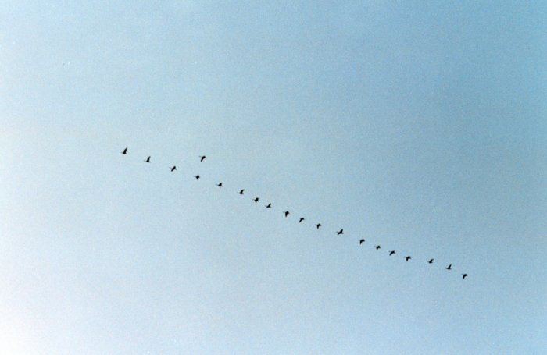
Canada Geese in the V formation, NOAA Photo Library
The use of a formation by which birds fly a short distance behind the wing tip of the bird in front of them (often called the "V" or squadron formation) saves energy, allows the birds an unobstructed view, and permits them to communicate. The strongest and most dominant bird takes the lead position. When she flaps her wings, the down-beat forces air to roll off of her wing tip creating a vortex that is similar to the wake of a boat. The bird behind her surfs on this vortex making his or her flight a little easier. In this formation, each bird in turn, as it flaps its wings, assists the birds behind it. Birds arrange themselves so that the weakest birds are last. In this manner the entire flock, from the strongest bird to the weakest bird can fly at the same speed. It has been estimated that geese can fly 70 percent farther by using the V formation rather than by flying solo.

During their migrations, birds that fly long distances primarily by flapping their wings can cross oceans and seas from which they can get no food or water. For example, the tiny Wood Thrush crosses the Gulf of Mexico. The Arctic Tern flies from the Arctic to the Antarctic and back, a phenomenal round trip that can be as long as 22,000 miles (35,400 km) per year. The long-tailed jaeger, another sea bird, flies 5,000 to 9,000 miles in each direction. Journeys of 2,500 miles per year are made by some cranes. The tiny barn swallow flies more than 6,000 miles in its annual migration.
The ruby-throated Hummingbird makes the longest migration of any animal in terms of body length, at about 48,600,000. Ruby-throated Hummingbirds, tiny birds less than 3.5 inches in length and weighing only 3.5 grams, travel to staging places in the Gulf coast of the United States. There they feed on the pollen of flowers and gain weight. When they have stored enough fat for the journey and when conditions are right, they set off. Flying sometimes more than 30 hours without setting foot on dry land or on a branch, they travel 500 miles non-stop to the Yucatan peninsula.
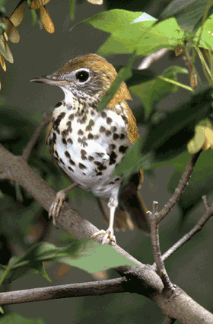
Wood Thrush - Crosses Gulf of Mexico
U.S. Fish & Wildlife Service
Taxonomy of the Ruby-throated Hummingbird. The class of vertebrate animal species called Aves (which means "bird" in Latin) contains about 30 orders (for example - waterfowl, hummingbirds and swifts, penguins, and owls).
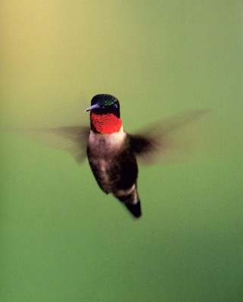
Ruby-throated hummingbird
National Park Service Photo
The 30 Orders of the Class Aves include about 180 families. The Order that includes hummingbirds and swifts (Apodiformes), contains three families: swifts, crested swifts and hummingbirds. Apodiformes are birds with very short legs and very small feet. They are among 180 different Families within orders of the Aves Class. Each Family is divided into Genera (plural for Genus). There are about 2,000 Genera, in the 30 different Orders and 180 separate Families in the Class Aves. More than 100 of these Genera are in the hummingbird Family (called Trochilidae). The particular Genus of the hummingbird Family that includes the ruby-throated hummingbird is called Archilocus. It contains two Species. In total there are about 10,000 different Species within the Class Aves, i.e., there are 10,000 species of birds.
AVES → 30 Orders → 180 Families → 2,000 Genera → 10,000 Species of birds.
The taxonomy for the ruby-throated hummingbird is:
Kingdom: Animalia
→ Phylum: Cordata
→ Subphylum: Vertebrata
→ Class: Aves (birds)
→ Order: Apodiformes (hummingbirds and swifts)
→ Family: Trochilidae (hummingbirds)
→ Genus: Archilocus (ruby-throated hummingbirds)
→Species: Archilocus Colubris (ruby-throated hummingbird)

Migrating birds vary their altitude to take advantage of weather conditions and wind currents. To fight a headwind, most birds stay low, where ridges, trees, and buildings slow the wind. Birds will ride a tailwind as long as possible. Bar-headed Geese have been recorded flying across the Himalayas at 29,000 feet, higher than Mount Everest. Other species seen above 20,000 feet include the Whooper Swan, the Bar-tailed Godwit, and the Mallard duck.
Some birds who are mountain or moorland breeders, such as the Wallcreeper and White-throated Dipper, migrate by changing the elevation of their range to leave colder, higher ground for lower, warmer elevations. Some birds, such as Merlins and Skylarks, will move further to the coast, which has a milder climate, or to a more southerly region. In periods of extreme cold, birds that are otherwise non-migratory will change their locations. An example is the chaffinch. The species of this bird living in Britain is normally not migratory, but in periods of unusually cold weather chaffinch populations will temporarily move south or to Ireland.
What triggers migration? Physiological changes that allow birds to gain fat for the journey are governed by the pituitary and thyroid glands. However, these changes only allow birds to store the extra energy needed for the migration. Thus, the trigger for starting the long flight must be something sensitive to conditions which change every year. Possibilities are: the date of the arrival of spring, the timing of storms, the flowering of plants, the hatching of insects, increases in foliation, and the availability of food.
Almost certainly, different species have different sensitivities to climactic and environmental conditions. The Woodcock, Snipe, Lapwing, Starling, and Lark appear to depend on temperature and barometric pressure. Others, such as the Swift, Cliff Swallow, Baltimore Oriole, and Short-tailed Petrel are less weather dependent and their migrations occur with remarkable regularity each year. This is an undeveloped area of study and scientists don't know a lot about it.
Flyways and Funnels
A flyway is a route used regularly by migrating flying animals such as birds, bats, or butterflies. Flyways are like rivers with less important common migration routes or migration routes of individual species feeding into them like tributaries. Most flyways run generally north/south between northern breeding grounds and southern wintering grounds. Some of the generally north/south flyways have significant east/west movements. Flyways usually follow geographic features such as river valleys, coastlines, and mountain ranges.
Flyways are more prominent in North America than in any other continent. In North America they are usually classified into four: the Atlantic Flyway, the Mississippi Flyway, the Central Flyway and the Pacific Flyway. North America, before the population of the continent by Europeans, had broad expanses of forest, tundra and wetlands that were ideal for migratory birds. This is changing as the wetlands are filled in, the forests cut down, and pollution increases. Some biologists contend that there are only three flyways combining the Central and the Mississippi flyways into one. Others find it convenient to refer to seven flyways in North America.
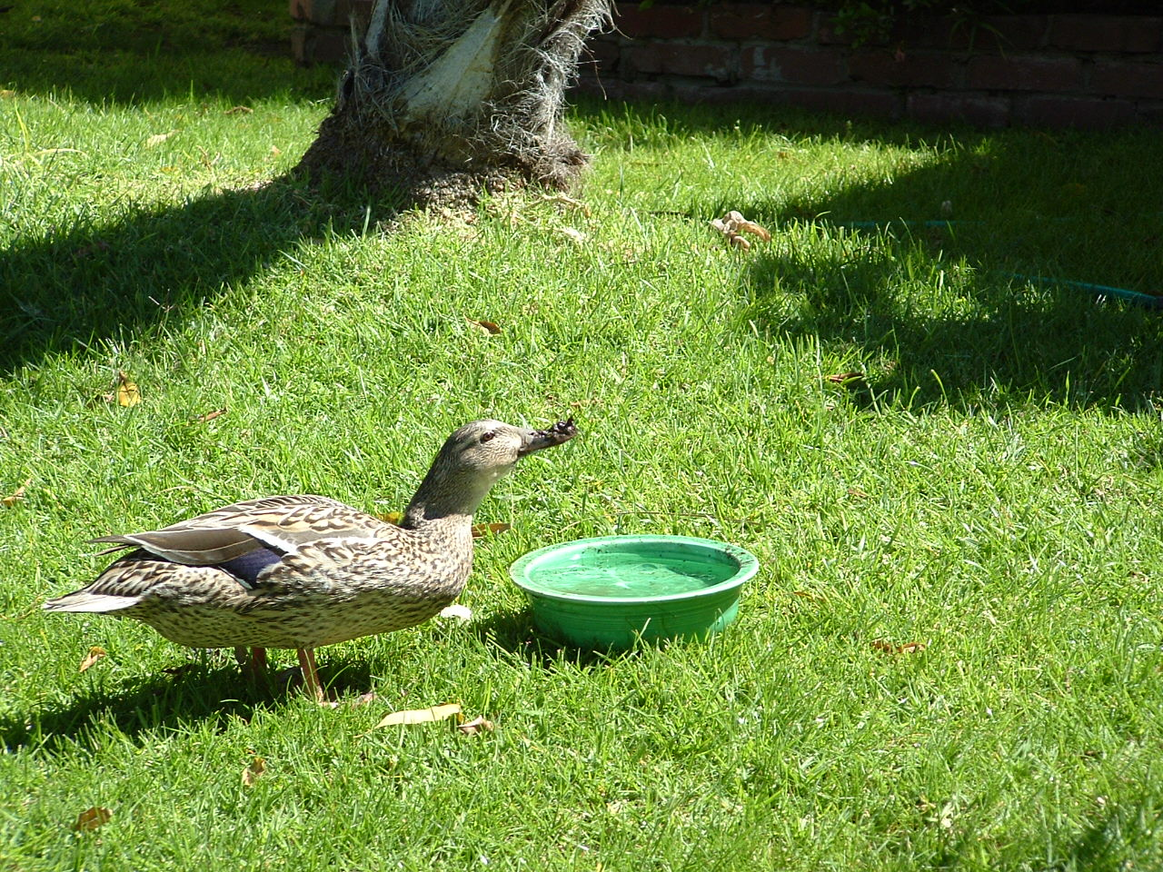
Mallard Drinking, Los Angeles, March, 2005
This species can fly at elevations of 4 miles.
Photo by TeachWithMovies.com, Inc.
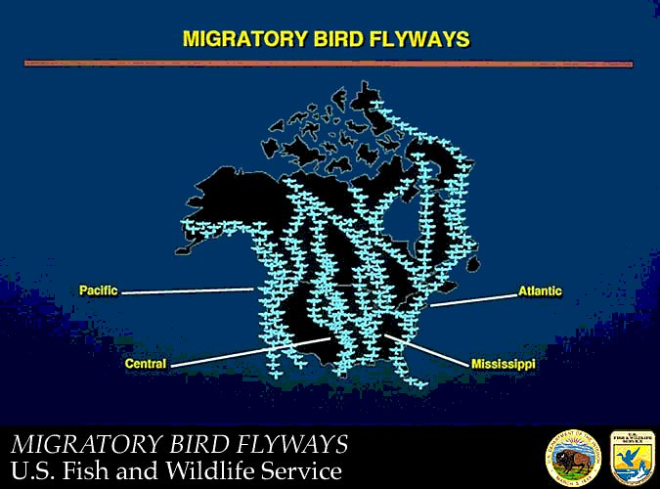

All North American flyways except for the Atlantic Flyway converge in Mexico or Central America. (Some long distance migrators fly from the far north, over the Mississippi or Central flyways, directly across the Gulf of Mexico to South America.) The Atlantic Flyway crosses the tip of Florida, the Caribbean Sea, and ends up in South America. For the Atlantic and Pacific Flyways the difference in temperature between land and sea gives rise to constant breezes which the migrating birds can use to help keep their elevation. Birds use the coastline to orient themselves and find their way. The Sierra Nevada and the Appalachian Mountain ranges generally run north/south and generate updrafts as they deflect winds. There is (or was) abundant food along the shorelines and in the wetlands. The Mississippi river system also provided another north/south conduit and wetlands that provided food. Unfortunately, as wetlands have been destroyed by development and pollution increases, the viability of these flyways has diminished.
The flyways of Eurasia and Australasia include: the East Asian-Australasian, the Central Asia/India, the West Asia/Africa, the Mediterranean/Black Sea and the East Atlantic Flyways. In South America there are established migration paths from near the southern tip of the continent. Various routes of migration go north into the Amazon Basin, north to the Plate River in Argentina, and, skirting the Andes, north to Central America.
Flyways can be only a few hundred meters wide at certain points, such as mountain passes and the crossing points of water bodies. These strategic points are called funnels. In other places flyways can be hundreds of kilometers wide. Birds on different migratory flyways may share stopover sites and breeding areas. Some species of birds don't always fly the whole course of a flyway, stopping when they reach their home range.
Large bodies of water such as oceans and seas do not create the thermal updrafts needed by raptors, storks, cranes and some other birds to gain altitude for long distance migrations. Mountains do not provide good consistent thermals. Thus birds that use updrafts to gain altitude are forced to keep to flat land areas and cross large bodies of water at their narrowest points.
During migration, massive numbers of raptors pass through funnels such as Gibraltar (where Europe and Africa almost touch at the entrance to the Atlantic Ocean), Falsterbo (where the Scandinavian Peninsula is closest to the Danish Islands that provide an easy route to the European land mass) and the Bosphorus (a narrow band of land between the Black Sea and the Sea of Marmara). At each of these funnels, hundreds of thousands of birds that use thermal updrafts to gain altitude in their migrations cross in a narrow stream. They spread out when the land mass widens. For example, the birds coming from Eastern Europe through the Bosphorus spread out through Turkey and around the eastern end of the Mediterranean Sea only to bunch together again to cross the north end of the Suez Canal into Africa. In the Americas, Vera Cruz, Mexico is a vital link in raptor migration. Birds of prey migrating between North and South America can't find good thermals in the mountains west of Vera Cruz. Nor can they fly over the Gulf of Mexico (more specifically the "Bahia de Campeche") which is to the east because oceans do not create thermals. The raptors are required to fly along a strip of land along the coast. At Vera Cruz, that strip is only 25 miles wide creating a dramatic funnel.

Bird Navigation
All navigation is dependent upon two things: a map to show the traveler where to go and a compass to indicate the direction of travel. Scientists have studied the navigation capacities of birds in two contexts: homing behavior and migration.
Birds have amazing powers to return home. For example, a Laysan Albatross returned to Midway Island in the Pacific after it was released at Whidbey Island, Washington, a journey over open sea of some 3,200 miles (5,100 km). The bird made the trip in 10 days. Other examples are: a swallow: 1,100 miles(1,800 km); a Manx Shearwater: Massachusetts to Britain, 3,050 miles (4,900 km) across the Atlantic in 12 1/2 days; and a starling 500 miles (800 km).

A bird taken from its home range will fly in a spiral pattern until it finds a landmark it recognizes. It then heads straight home. Topographic features that might be used by birds are mountains, rivers, and coast lines. To help find their way home, birds have also been known to use ecological and climactic markers such as vegetation zones, prevailing winds, and air masses of different temperature and humidity. Birds can also obtain guidance from their sense of smell. A good example is homing pigeons. They can remember the different odors that reach their lofts on winds from varying directions. For example, if a pigeon's loft has a particular scent that comes to it on westward winds and it is transported to the west away from the source of the scent, it will fly in a direction that makes the scent stronger, i.e. to the east, to return home.
The location and direction of the sun, the position and location of the stars, and the earth's magnetic field are also used by birds to guide them on their journeys. No one is sure exactly how birds use these navigational tools and in what combination or if these are the only aids to other methods of navigation that birds use.
Nor do scientists know how birds use the sun as a navigational tool. Birds may know instinctively or by memory what the location of the sun should be in the sky at particular times of the year or at certain times of the day and fly toward locations in which that will occur. The sun, would in effect, act as a compass. Alternatively, birds may calculate the angle made by the plane through which the sun is moving in relation to the horizontal, knowing by instinct or memory what it should be in their home area. In the Northern Hemisphere, the highest point reached by the sun always lies in the south and is reached at noon. This could show birds the direction and time allowing them to compare the curve of the sun's movement with circumstances in the bird's usual habitat.
Some birds use the magnetic field of the earth to allow them to fly in a constant direction no matter where they are released with respect to their home area. Some scientists believe that birds also use the magnetic field of the earth to sense their location. It is likely that small crystals of magnetite inside the bird's bodies act as a compass.
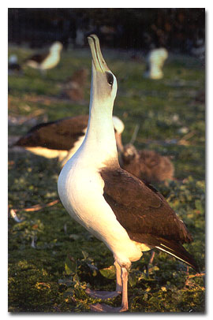
Laysan-Albatross Sky Pointing
a mating ritual behavior
Model for the Evolution of a Migratory Flock and a Migratory Species
How are migratory patterns established? It begins with a permanent non-migratory resident population that expands its range due to competition within the species. Pressures for migration start if the range expands into an area in which there is a lot of seasonal change and which provides more food during the breeding season (the far north in the summer) but a harsher climate and reduced food availability during the non-breeding season (the far north in the winter). Individuals breeding in these new regions at the fringe of the species' distribution (the proto-migrants) will be more productive because there is more food in the regions in which they breed. They need to improve their chances of survival during the non-breeding season in which the climate in the fringe areas is harsher and provides less food. Those birds that return to their ancestral range during the non-breeding season to take advantage of the food that is there will have the advantage of enjoying the best food in the breeding season (the north in summer) and the best food in the non-breeding season (the south in winter). As the fringe of the range expands outward, the journey back to the ancestral range to feed during the non-breeding season becomes longer and longer.

Because a migrant population gains an advantage on both its breeding and wintering range, it becomes more abundant, while the resident, non-migratory population becomes proportionately smaller and smaller in numbers. If changing environmental conditions become increasingly disadvantageous for the resident population or competition for food becomes more severe, the resident population could eventually disappear, leaving the migrant population as characteristic of the species. Or, the two flocks can separate physically. Eventually they will become different species of birds. These stages in the evolution of migration are represented today by species which are permanently resident, partially migratory, and fully migratory. As for all adaptations, natural selection continues to mold and modify the migratory behavior of birds as environmental conditions perpetually change and species expand or retract their geographic ranges. Hence, the migratory patterns that we observe today will not be the migratory patterns of the future.

The Common Yellowthroat of the Atlantic coast is a good example of the process of migratory and non-migratory flocks separating. Birds that breed in the most southern part of the species' range in Florida are largely non-migratory, whereas populations that breed as far north as Newfoundland migrate to the West Indies in the winter, well removed from the resident population in Florida. Eventually, flocks of birds of the same species which are physically separated will develop into different species.
Dr. Craig Stanford of the University of Southern California described this process in an interview with TeachWithMovies.com using chimps, bonobos and squirrels as examples:
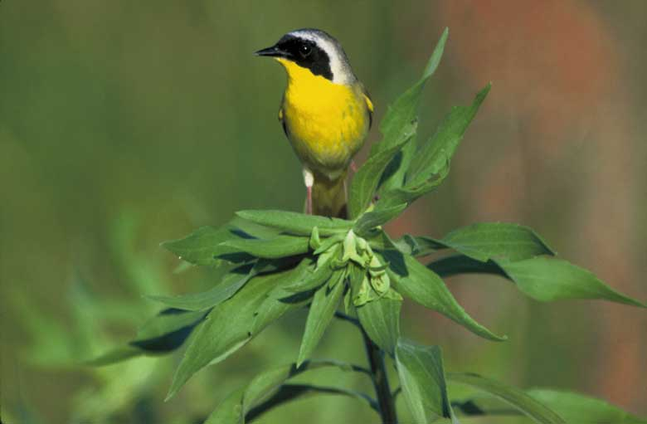
Common Yellowthroat - U.S. Fish & Wildlife
Example of Migratory/Resident Flock Separation

TWM: What about the bonobos and the chimps? Are they super close genetically . . . and their ranges, do they overlap?
Dr. Stanford: Yes, they are very close because they're basically both variants of the same animal. And no, the ranges don't overlap, they're adjacent. If you go back a million and a half years or maybe less, you'd find there was one ape that looked like the two of them combined, and that what almost certainly happened is that this huge river, the Congo River, which is like the Mississippi, probably changed course at some point and divided what had been this ape's range into two pieces, most of it to the North of the river and then a little bit of it in the South. Those two animals were the same animal, and then over thousands of generations, you know, mutations happened. There was no more gene flow. There was no migration back and forth across the river. As a result the chimpanzees were isolated in the North; the bonobos to the South.
TWM: Just because of the separation of the river?
Dr. Stanford: Well, that's the way most species are formed, right? That's why, if you go to the Grand Canyon and you go to the North Rim and compare the animals there to the South Rim animals you find that there are these slight differences. The squirrels on the North side are very similar to the ones on the South side. You look at their genetics and you find that they've been separate from the squirrels on the other side for exactly the length of time the canyon has been there. They go their separate ways. There's no longer any contact. A mutation happens here that doesn't happen there . . . . there's no more migration. The genes don't cross the canyon, so, a thousand years later you have squirrels with pointy ears here and not there. (See Interview With Dr. Craig Stanford at TeachWithMovies.com.)

Bird species are extremely old. The continents were much closer 50 million years ago than they are today. As the continents drifted apart, migration patterns changed. In addition, in the "recent past", the last two million years, there have been approximately six ice ages. These, too, bring about changes in the location of breeding areas and winter feeding grounds.
While migration confers definite benefits, there are risks as well. A major risk is predation, particularly from man. However, other birds will prey on migrants. There are also storms and the risk of losing direction over a desert or an ocean. An example of the risks is shown by the Hawaiian Goose. These are Canada Geese who were blown or flew off course by about 2000 miles. Fortunately, they sighted the Hawaiian Islands and landed there. They were never able to make it back to the mainland and their normal migration routes. Isolated in the tropics for millions of years, they have adapted to higher altitudes among the mountains of Hawaii and lost most of the webbing in their feet. They have now become a resident, non-migrating population. If they are not already a separate species of geese, they will become one. You can see Hawaiian geese at the Waimea Canyon on Kuai.

Migration patterns are affected by man-made changes in the environment such as deforestation, the draining swamps and marshes, and urban development. These eliminate fields for foraging and prey for hunting. Natural causes also affect migration patterns. These include climate changes (particularly ice ages) and shifts in the positions of islands and continents as a result of tectonic drift.
Reintroducing Migratory Behavior in the Eastern U.S. Whooping Crane Flock
Whooping Cranes are beautiful and graceful birds. They are the tallest birds that nest in North America, the male reaching 4.5 feet (1.5 meters) in height. Whooping Cranes have a long neck, a long dark pointed bill, and long thin black legs. The wing span of an adult Whooper measures six feet (2 meters). Its body is white and its wings are white except for the tips which are black.
Whooping Cranes fly long distances like a glider. Gaining elevation from thermal updrafts, they spiral down to about 70 meters above the ground until they find a new updraft. Spiraling and gliding conserves energy and allows these large birds to travel long distances. Whooping cranes in flight can be distinguished from other birds by their long necks extended forward and legs that trail straight behind.
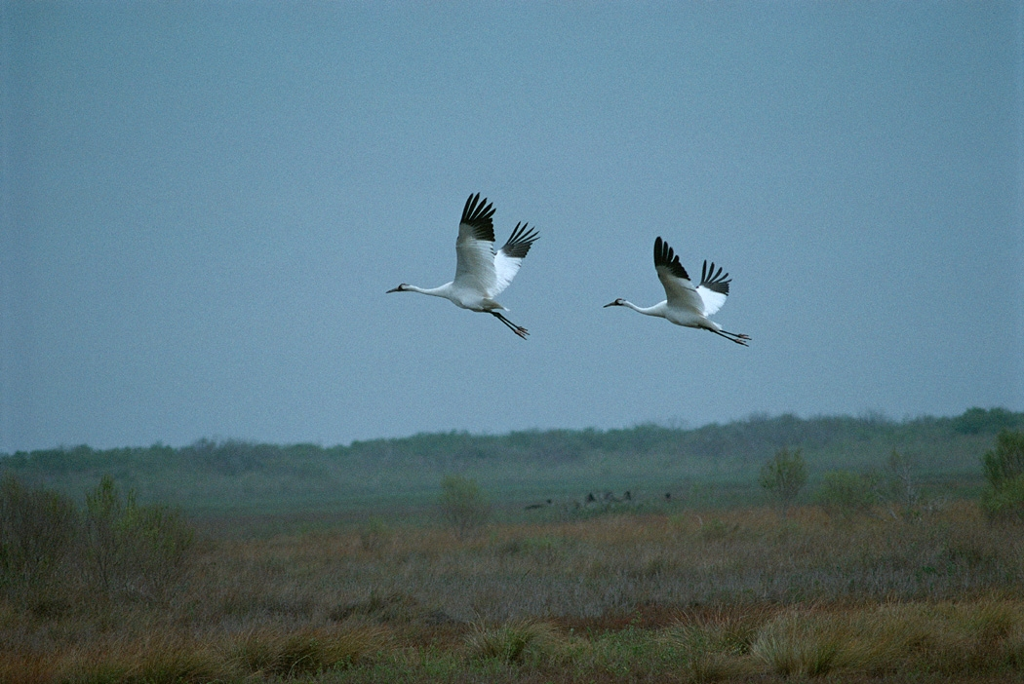
Whooping Cranes in Flight
In 1941 the population of the last remaining migrating whooping crane flock was only 15 individuals. There had never been a lot of whooping cranes. Only an estimated 1400 in 1860, but in 1940 the species appeared to face the loss of its migrating behavior. Environmentalists and government agencies responded and by 1999 the migrating flock had grown to about 180 birds. Their summer breeding grounds are in Canada's Wood Buffalo National Park and their wintering grounds are at the Arkansas National Wildlife Refuge in Texas. There were also resident, non-migrating whooping Cranes living in a number of sanctuaries in the U.S. and Canada.
Scientists recognized that if the entire population of migrating whooping Cranes used the same wintering and breeding locations, the whole flock could easily be wiped out by human impacts, disease, or sudden changes in the weather. In the 1990s efforts began to develop a second migrating flock. These met with failure until scientists teamed up with William Lishman, who had learned to lead Canada Geese chicks on migration routes using ultralight aircraft.
Young whooping Cranes, like most other birds, will "imprint" on the animals that they first see and hear after they are born. In the wild these are the chicks' parents. Imprinting is an essential step in the development of young whooping Crane chicks because they don't know instinctively how to catch food, which food to catch, or how to fly. They have to be taught these skills by their parents.
To establish a new migrating whooping Crane flock, scientists needed the birds to imprint on the sounds of ultralight aircraft and the non-human, crane type costumes donned by their caretakers. When the birds were ready to fly, they followed the ultralight aircraft on exercise runs and finally on a migration to southern wintering grounds. The next Spring, on their own, the birds retraced their flight to the location where they hatched.
Reintroducing birds to a migration route is a complex undertaking. Wintering and summering grounds and rest stops along the migration route must be secured. A source of eggs for new hatchlings must be found. Government permissions must be obtained. Whooping Cranes are too scarce to experiment using their eggs, so a closely related non-endangered species must be located to be used for trial runs.
A partnership of conservation organizations and government agencies, called the Whooping Crane Eastern Partnership (WCEP), undertook the task. Ultralight aircraft would lead the birds from a new breeding ground in the Necedah National Wildlife Refuge in central Wisconsin to a new wintering ground at the Chassahowitzka National Wildlife Refuge on the west coast of Florida. At first, trial runs were attempted using Sandhill Cranes, a non-endangered close relative of the whooping crane. A migratory path with stopovers for rest and feeding was established and some of the cranes returned on their own to the hatching site the next Spring. However, the cranes had lost their fear of people and would land in school yards and other places where people congregated. To maintain the wildness of a reintroduced migratory flock, human contact had to be all but eliminated.
After testing methods of insulating another group of Sandhill Cranes from human contact, the WCEP tried its first migration of whooping cranes, led by Mr. Lishman and his partner in Operation Migration, Joe Duff. It was successful and efforts to increase the flock have continued each succeeding year. In 2005 the new Eastern Whooping Crane migrating flock consisted of 46 birds.
Whooping Crane Migration Routes
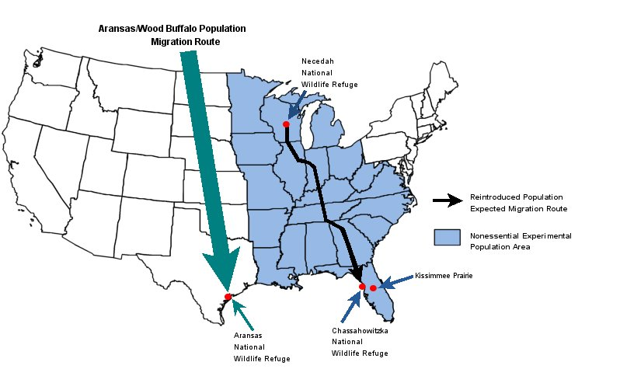
Wild migration route shown by green arrow.
Reintroduced Eastern flock migration route shown by black line.
Source: U.S. Fish and Wildlife Service.
Conclusion

Avian migration shows how the drive to gain evolutionary advantage leads animal develop interesting and complex behaviors.

Written by James Frieden. Last revised May 26, 2009.

