ALICE PAUL AND THE STRUGGLE FOR THE 19TH AMENDMENT:
WHAT REALLY HAPPENED

Setting the Scene – 70 Years of Frustration for Women Seeking the Vote
The movie “Iron Jawed Angels” describes a battle between Alice Paul, a slight young Quaker woman demanding women’s suffrage, and President Woodrow Wilson, resisting reform.
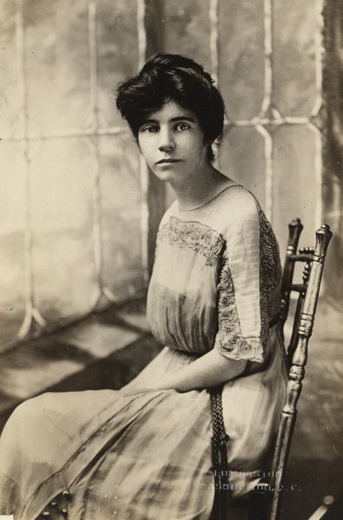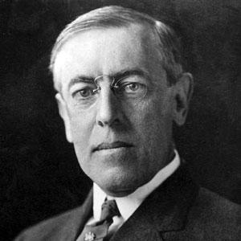
Alice Paul President Woodrow Wilson

However, the struggle wasn’t really between two people. It was between two forces, with Wilson, who was a progressive politician and came to believe in woman’s suffrage, caught in the middle. One force was the centuries old belief in male dominance and female incapacity, supported by long observed traditions, both religious and secular. Through the beginning of the 20th century, with very few exceptions, women had enjoyed no political rights. A woman’s place was in the home; her role in life was to serve her husband and raise children. In addition, resistance to women’s suffrage in the United States was funded by powerful industries. The liquor industry was rightly convinced that if women got the vote, prohibition of the production and sale of alcoholic beverages would soon follow. Other industries were worried that if women got the vote, restrictions on child labor and other reforms would hamper their businesses.
On the other hand, by 1912, American society had started to change its views. Millions of women and men had come to realize that women should be allowed to take a larger role in society. In the latter part of the 19th century, women had been admitted to colleges, although only in small numbers compared to men. The prohibitions on married women owning their own property and collecting their own wages were dropped. There were a few female doctors, lawyers and ministers. Change was also being felt in the suffrage arena. By 1912, women could vote in nine sparsely populated states in the West and they were permitted to vote in some other states on a few issues considered within their special areas of expertise, such as elections for members of school boards.
Moreover, women’s suffrage was supported by the long sweep of history. The story of Western civilization in the modern age has been, overall and with some backsliding, a movement toward granting rights and equality to ever more people. The franchise is a case in point. During the Middle Ages, only kings and nobles had a voice in government. When democratic institutions first began to take hold, only well-off male property owners could vote. Slowly the franchise was extended to all white men regardless of their financial condition. After the Civil War, black men were permitted to vote, although hampered by discrimination in the South. Still, as of 1912, most American women - almost half the nation - had no voice in deciding who would be their governor, their state legislators, their senators or congressman or their president.
As far back as 1848, thirteen years before the Civil War, a few women, joined by some extraordinary men, issued the Seneca Falls Declaration, demanding women’s suffrage. Little progress toward women’s suffrage was made throughout the 19th century. When Susan B. Anthony tried to vote in 1873, she was convicted of a misdemeanor.

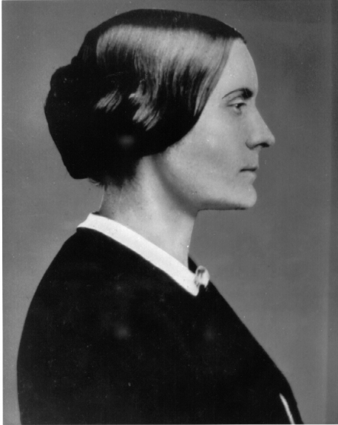
Susan B. Anthony
Invited to make a statement before she was sentenced, Miss Anthony defied the court, stating:
My natural rights, my civil rights, my political rights, my judicial rights, are all alike ignored. Robbed of the fundamental privilege of citizenship, I am degraded from the status of a citizen to that of a subject; and not only myself individually, but all of my sex, are . . . doomed to political subjection under this, so-called, form of government.

Miss Anthony refused to pay the fine, expecting to be imprisoned. The court then ordered that the fine was not to be collected.
To readers in the 21st century it seems obvious that women have a natural and inalienable right to vote. However, in 1912, while there were nine suffrage states, in many other states campaigns to give full voting rights to women had been soundly defeated. After more than 70 years of suffrage activity, the effort to enfranchise women was largely a tale of frustration.
During the Civil War and for years after the war, suffrage leaders had bowed to the wishes of other progressives to focus on obtaining the vote for black men. However, beginning in 1878, suffragists sought to pass a national constitutional amendment enfranchising women. The suffrage leaders during the 19th century were Susan B. Anthony, Elizabeth Cady Stanton and Lucy Stone. They were assisted by a few men, the most remarkable of whom was Frederick Douglass, the former slave and abolitionist leader who was a steadfast supporter of women’s suffrage.
After the failure of the initial effort to pass a constitutional amendment granting women the right to vote, the suffrage movement focused on efforts to get individual states to extend the franchise to women. In the first decade of the new century, picking up where Anthony and Stanton had left off, the National American Women Suffrage Association (NAWSA), led by Carrie Chapman Catt and Anna Howard Shaw, attempted to invigorate the movement.
At pivotal moments, the United States has been graced by extraordinary leaders. Examples include: the Founding Fathers; Abraham Lincoln; Woodrow Wilson; Theodore Roosevelt; Franklin Delano Roosevelt; and Martin Luther King, Jr. There is an argument that the combination of Alice Paul and Carrie Chapman Catt belongs in this select group. President Wilson, a great leader in many other respects, was slow to see the importance of women’s suffrage and had to be maneuvered into a leadership role on this issue. It could rightly be said that Alice Paul and her angry militants put the President on the hot seat and pushed him to support the 19th Amendment, while Mrs. Catt and NAWSA won women the right to vote in roughly half the states and provided positive political incentives to the President that led him toward the constitutional amendment.
Historians traditionally gave Mrs. Catt and NAWSA most of the credit for the passage of the 19th Amendment. Recently, some historians have argued that Alice Paul and her NWP militants were important forces promoting the Amendment. This article will give background for Miss Paul, describe her tactics and the government’s response.

An American Quaker Pursues Her “Testimony”
Alice Paul was born in 1885 in Moorestown, New Jersey. She was raised as a Quaker, a Christian sect which is nonviolent, pacifist and active in movements for social reform. The Quakers follow the teachings of George Fox, an Englishman who, beginning in 1647, advocated the doctrine of “inner light” or “Christ within”. Quakers believe that following the true path of Jesus means improving the lives of others. They are encouraged to select a “testimony”, a life’s work with a goal of reform. Fox described it as being “valiant for Truth upon earth”. Quakers were very active in the movement to abolish slavery. Like many other Quakers, the Paul family believed in gender equality, education for women, and working to reform society.
Quakers, like other Christians, understand the power of “bearing witness” which has also been used by many movements for social reform, including the abolition movement and later the Civil Rights Movement. Bearing witness is to show by your presence or by the way you act that something is true or right. Even today, advocates of social change use the power of bearing witness. “Ethical vegans”, a small but growing minority, believe that people should not eat animals that have been tortured and killed on farms, particularly on large scale factory farms. Vegans point out that people can get all the nutrition they need from a plant based diet and that liking the taste of meat is no reason to kill or torture fellow creatures. For vegans, eating is an expression of their beliefs. It is hard for them to sit down to a meal with meat eaters and watch as others eat what the vegans see as products of torture and killing. But many of them do it because, by their refusal to eat meat or dairy foods, vegans are bearing witness, trying to get the meat eaters to think about what happens to food before it reaches their plates.
Alice Paul excelled in school and was one of the relatively few American women of her time to pursue higher education. After graduating from Swarthmore College, she committed herself to a testimony of improving the social and political status of women. She tried social work, but felt that the impact of helping individuals could easily be lost so long as women were powerless. Miss Paul then went back to school, earning a Master’s degree in sociology from the University of Pennsylvania in 1907. She furthered her education in England at a Quaker school for social activists and the London School of Economics.
While Miss Paul was in England, she became involved in the British suffrage movement and met its leader, Emmeline Pankhurst. British suffragettes, as they were called, used protests, civil disobedience, and even limited acts of violence to promote their cause. In England, Miss Paul participated in demonstrations and was several times arrested and imprisoned. In jail she engaged in hunger strikes and was forcibly fed by prison authorities. The conditions in prison caused her to suffer serious health problems. However, Alice Paul had found a cause through which she could carry out her testimony. “She envisioned a suffrage campaign not as simply a means to an end – getting the vote – but as an opportunity to change first women’s thinking about themselves and then their status as American citizens.”
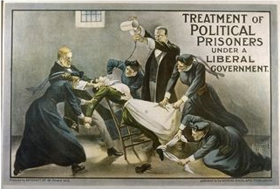
Force Feeding a Suffragette: A poster from the British Suffrage Movement

In a London police station after one arrest, Alice Paul met Lucy Burns, another American active in the British suffrage movement. Miss Paul returned to the U.S. in 1910 and entered a PhD program in sociology at the University of Pennsylvania. She also became active in the U.S. suffrage movement. Lucy Burns returned to the U.S. from England in 1912, the same year that Miss Paul earned her degree. Together they decided to join forces to seek a constitutional amendment providing for women’s suffrage. Alice Paul was 26 years old. Lucy Burns was 33.
At that time, NAWSA leaders believed that passage of a national suffrage amendment was impossible. However, the NAWSA Board did allow Paul and Burns to take over its Congressional Committee in Washington, D.C. giving them a budget of only $10 and a few volunteers.
Advocating for a Constitutional Amendment - Nonviolence and Dramatic Imagery
The traditional means by which American women had sought suffrage involved education and state political campaigns in which they tried to convince a male electorate to give women the vote. Alice Paul took a different and more confrontational path. Her tactics had two hallmark characteristics: non-violence and dramatic imagery. Miss Paul’s commitment to nonviolence was rooted in her Quaker upbringing and furthered by her education. As a young girl, she had studied Henry David Thoreau’s “Civil Disobedience”, which championed the use of nonviolent resistance in order to respond to the wrongful acts of government. Paul also read the works of Russian novelist and social reformer Leo Tolstoy, who believed that “only nonviolent resistance to the daily tyranny of institutionalized injustice would be the appropriate tool for achieving change.” Another activist developing methods of peaceful social and political reform at the same time as Miss Paul was Mohandas Gandhi, whose methods of forcing governments and societies to eliminate injustice through nonviolent protest were used throughout the world during the 20th century. Historians have been unable able to find Gandhian sources for any of Miss Paul’s tactics. However, the NWP’s protest campaign used many of the techniques employed by Mr. Gandhi. It appears that Gandhi and Paul were pursuing parallel tracks without much knowledge of what the other was doing.
“Nonviolent” doesn’t mean “passive” or “inactive”. Quite the contrary. Alice Paul organized parades, petitions, train tours, meetings with the President and other leaders, and political campaigns. She started pickets, protests and boycotts. She formed talking tours and organized the famous “Silent Sentinels” who manned picket lines at the gates of the White House and the Capitol. Miss Paul and her associates published a newspaper called The Suffragist.
Protests organized by Alice Paul had two purposes: one was to champion the cause of suffrage and the other was to elevate the status of women in their own eyes and in the view of society as a whole. For example, under Miss Paul’s leadership, suffragists gathered 250,000 signatures for a petition to present to the Senate and held a demonstration in 1913 in which women drove cars to the Capitol from all parts of the country. At that time “a woman driving was a dangerous and usurping event in itself.” This display, showcasing that women were perfectly capable of driving, culminated when the women “left their cars and brought their 250,000 signatures into Senate offices [which] caused a serious debate on suffrage on the Senate floor.”
Miss Paul was very much aware of the power of visual displays that would lead to newspaper stories and engage the public’s attention. From the March 1913 parade that stole the show from President Wilson’s arrival in Washington for his inauguration, to the Silent Sentinels that picketed the White House through all kinds of weather, despite being assaulted by angry crowds, and in the face of arrest by the police, Alice Paul was a master at using visual images to highlight her protests. This is graphically shown by the parade and picketing scenes in the movie.
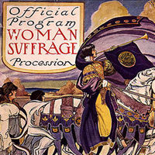
The Official Program of the March, 1913 Suffrage Parade

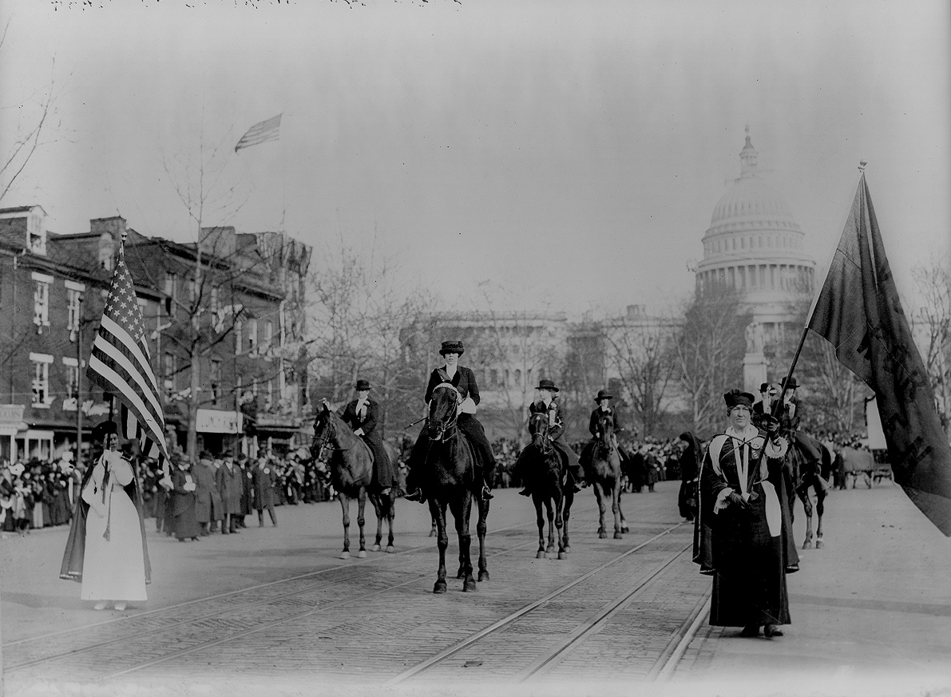
Head of the March, 1913 Suffrage Parade

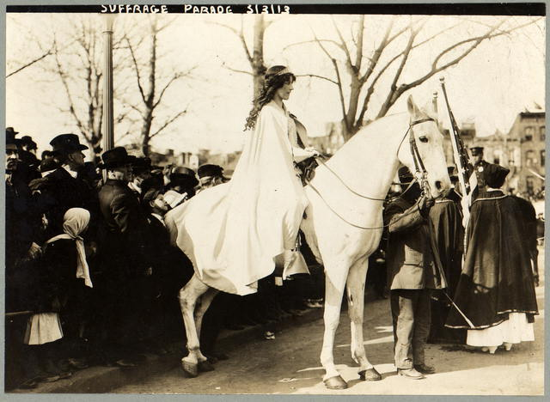
Inez Milholland on a White Horse during the March, 1913 Suffrage Parade
Chafing under control by NAWSA, Paul and Burns formed the Congressional Union, an independent national organization of women who saw the importance of focusing on a constitutional amendment. NAWSA leaders worried that the hard work of the past decades would be tossed away by a “dangerous” woman who was “siphoning energy and money away from state campaigns . . . refashioning the movement through the force of her own personality.” Alice Paul and Lucy Burns took their followers out of NAWSA, eventually establishing the National Woman’s Party (NWP), devoted to mobilizing support for a constitutional amendment in the states in which women were allowed to vote. The NWP pulled in “single and self-supporting [women], both college-educated professionals and . . . blue-collar workers”. While NAWSA was more associated with older, refined women, 87% of recruiting organizers for the new NWP were between nineteen and twenty-nine.
Alice Paul In the Midst of the Suffrage Campaign
Here is a description of Alice Paul by an NWP activist, Doris Stevens. The excerpt is from Ms. Stevens’ book Jailed for Freedom:
Most people conjure up a menacing picture when a person is called not only a general, but a militant one. In appearance Alice Paul is anything but menacing. Quiet, almost mouselike, this frail young Quakeress sits in silence and baffles you with her contradictions. Large, soft, gray eyes that strike you with a positive impact make you feel the indescribable force and power behind them. A mass of soft brown hair, caught easily at the neck, makes the contour of her head strong and graceful. Tiny, fragile hands that look more like an X-ray picture of hands, rest in her lap in Quakerish pose. Her whole atmosphere when she is not in action is one of strength and quiet determination. In action she is swift, alert, almost panther-like in her movements. Dressed always in simple frocks, preferably soft shades of purple, she conforms to an individual style and taste of her own rather than to the prevailing vogue.

. . . I have seen her very presence in headquarters change in the twinkling of an eye the mood of fifty people. It is not through their affections that she moves them, but through a naked force, a vital force which is indefinable but of which one simply cannot be unaware. Aiming primarily at the intellect of an audience or an individual, she almost never fails to win an emotional allegiance.

I shall never forget my first contact with her. I tell it here as an illustration of what happened to countless women who came in touch with her to remain under her leadership to the end. I had come to Washington to take part in the demonstration on the Senate in July, 1913, en route to a much needed, as I thought, holiday in the Adirondacks.

"Can't you stay on and help us with a hearing next week?" said Miss Paul.

"I'm sorry," said I, "but I have promised to join a party of friends in the mountains for a summer holiday and . . ."

"Holiday?" said she, looking straight at me. Instantly ashamed at having mentioned such a legitimate excuse, I murmured something about not having had one since before entering college.

"But can't you stay?" she said.

I was lost. I knew I would stay. As a matter of fact, I stayed through the heat of a Washington summer, returned only long enough at the end of the summer to close up my work in state suffrage and came back to join the group at Washington. And it was years before I ever mentioned a holiday again.

. . .

A model listener, Alice Paul has unlimited capacity for letting the other person relieve herself of all her objections without contest. Over and over again I have heard this scene enacted.

"Miss Paul, I have come to tell you that you are all wrong about this federal amendment business. I don't believe in it. Suffrage should come slowly but surely by the states. And although I have been a life-long suffragist, I just want to tell you not to count on me, for feeling as I do, I cannot give you any help."

A silence would follow. Then Miss Paul would say ingenuously, "Have you a half hour to spare?"

"I guess so," would come slowly from the protestant. “Why?”

"Won't you please sit down right here and put the stamps on these letters? We have to get them in the mail by noon."

"But I don't believe …”

"Oh, that's all right. These letters are going to women probably a lot of whom feel as you do. But some of them will want to come to the meeting to hear our side."

By this time Miss Paul would have brought a chair, and that ended the argument. The woman would stay and humbly proceed to stick on endless stamps. Usually she would come back, too, and before many days would be an ardent worker for the cause against which she thought herself invincible.

. . .

Alice Paul brought back to the fight that note of immediacy which had gone with the passing of Miss Anthony's leadership. She called a halt on further pleading, wheedling, proving, praying. It was as if she had bidden women stand erect, with confidence in themselves and in their own judgments, and compelled them to be self-respecting enough to dare to put their freedom first, and so determine for themselves the day when they should be free. Those who had a taste of begging under the old regime [NAWSA] and who abandoned it for demanding, know how fine and strong a thing it is to realize that you must take what is yours and not waste your energy proving that you are or will some day be worthy of a gift of power from your masters. On that glad day of discovery you have first freed yourself to fight for freedom. Alice Paul gave to thousands of women the essence of freedom.

1916: Progress and Frustration; Two Plans to Win
By the end of 1916, the efforts of the NWP and NAWSA had made substantial progress. Due to the state by state campaign favored by NAWSA, a total of thirteen states, including one that was east of the Mississippi River (Illinois) had enfranchised women. New York was on the verge of becoming the first large Eastern state to enact suffrage. The Republican Party was firmly in the suffragist camp. The suffragist cause was supported by a majority in the U.S. House and Senate. In their 1916 conventions, both political parties had adopted resolutions in favor of suffrage to be granted on a state by state basis.
However, the suffragists still lacked the 2/3rds majority in Congress required to pass a constitutional amendment and the President, the most powerful politician in the country, while he had voted for women’s suffrage in his home state of New Jersey, still opposed granting suffrage to women through an amendment to the Constitution. In addition, suffrage campaigns in many states continued to meet defeat. The movement was dead in the water in the South.
After years of struggle and with the goal still out of reach, supporters of a constitutional amendment were becoming dispirited. What was needed was some new tactic that would inspire supporters and force the issue. In 1916, Catt unveiled her "Winning Plan" to campaign simultaneously for suffrage in the states and for the federal constitutional amendment, and to compromise for partial suffrage in the states resisting change. Alice Paul came up with a different plan that combined her sense of urgency with her commitment to nonviolence. The NWP would post “Silent Sentinels” at the gates of the White House and at the Capitol. The women would carry banners supporting their cause and stand in all kinds of weather and would speak only if spoken to. The Silent Sentinels would bear witness to the injustice with which they were treated and the powerful visual image of a picket line at the house of the President. They would stay until the President actively supported a constitutional amendment providing for women’s suffrage.
1917 – Picketing and the First World War
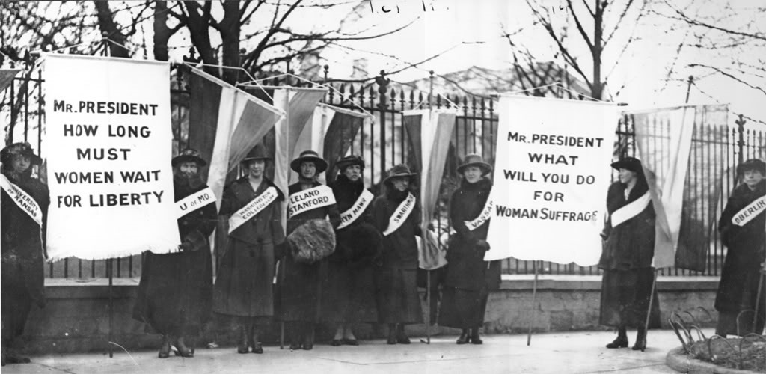
Daily picketing of the White House began on January 10, 1917. The suffragists stood close to the White House fence so as not to obstruct traffic along the sidewalk. They were determined to keep to their posts. On several bitterly cold days or days of rain and snow, President Wilson had his head usher invite the women into the White House for hot tea or coffee. They politely declined.
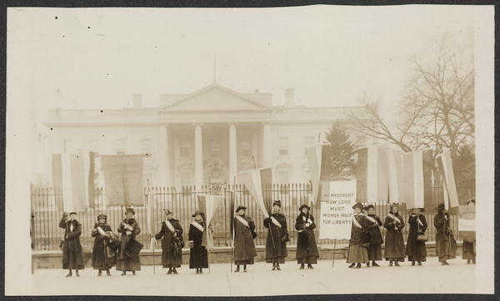

Miss Paul organized special picketing days: women from a single state, women who had attended college, women from different professions such as teachers, and a thousand pickets on the day of Wilson’s second inauguration. The picketing kept the suffrage issue in the public’s consciousness. By now, many agreed that women deserved the right to vote. The Silent Sentinels were making the statement that women were not going to be content until this right was granted.
The banners of the Silent Sentinels used every means possible to argue the cause of suffrage. President Wilson, who made eloquent speeches supporting the rights of the peoples of the world to democracy, saw his own words applied to women and turned against him on the banners at the gates of the White House.
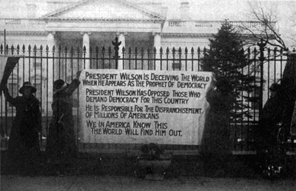

In 1917, President Wilson’s highest priority was to convince the U.S. to enter the First World War and then to unite the country behind the war effort. Mrs. Catt,
who had previously been a pacifist and a peace activist, saw an opportunity. NAWSA would support the decision to go to war and the war effort. Since the federal government was busy fighting the war, NAWSA would not press immediately for a suffrage amendment, but instead it would keep its focus on the state by state campaigns. NAWSA was a large organization of politically active women which could help mobilize support for the war effort. It was important for President Wilson to have NAWSA’s backing. In return, President Wilson, now a committed suffragist, though still adhering to the state by state strategy, would provide political support in the state campaigns.
While the advent of war created opportunities for NAWSA, it brought difficulties for the confrontational tactics of Alice Paul and the NWP. The First and Second World Wars were total wars in which the country was completely mobilized to support the war effort: every citizen was expected to contribute; vast numbers of young men volunteered or were drafted; raw materials were diverted to the military and consumer goods that people had taken for granted were no longer available. In the wars since WW II - Korea, Vietnam, Iraq and Afghanistan - Americans have not been asked to make such sacrifices.
It was assumed by many Americans that when the U.S. entered the war, members of the NWP, as patriotic citizens, would suspend their protests. Not so, reasoned Alice Paul: women couldn’t vote and had no say in the decision to go to war; therefore, they were not bound by it. The pickets stayed at their posts. This policy led to fierce attacks on Miss Paul and the NWP by NAWSA, cooperating with the President, by many of Miss Paul’s former supporters, and by many people outside the suffrage movement. These women thought that by demonstrating their value to a nation in time of war, women would be rewarded with the vote.
Alice Paul argued that this same logic had been used to delay the suffrage movement during the Civil War. She would not let that happen again. While thousands of women left the NWP, many more remained in the party. The pickets remained in front of the White House and the NWP continued as an effective political force until final ratification of the 19th Amendment.
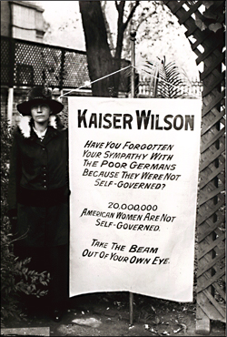
The banners were at times incendiary, such as the banner shown here. “Kaiser” was the title of the much vilified leader of Germany. America was fighting a war to “make the world safe for democracy,” in President Wilson’s famous statement. Yet, its own women were charging that they were being denied democracy. In terms of the Second World War, calling President Wilson “the Kaiser” would be like equating FDR to Adolf Hitler or to
the Emperor of Japan. Moreover, the comparison between President Wilson and the Kaiser was especially infuriating to the President and to the crowds that attacked the pickets because it contained an element of truth. Most American women had no voice in their government; for them the United States was, in effect, a tyranny.
When the NWP pickets used banners like the “Kaiser Wilson” banner, the police made no effort to protect them from the hostile crowds. When assaulted by rowdy crowds, Miss Paul and her suffragists kept their commitment to nonviolence. In fact, throughout the militant suffragist campaign, there was nothing more violent than a couple of broken windows. When the suffragists tried to hang on to their banners, they were dragged through the streets. Soldiers and sailors in uniform joined the attacks. Yet, it was only the protesters who were arrested for disorderly conduct or blocking the sidewalk, crimes they did not commit.
New pickets would appear after each day’s violence. On certain days, successive waves of picketers would immediately appear to replace those arrested. The women were demonstrating their strength and resilience; their commitment to the suffrage cause. The attackers and the police were in a morally indefensible position and ceded the moral high ground to the protesters.
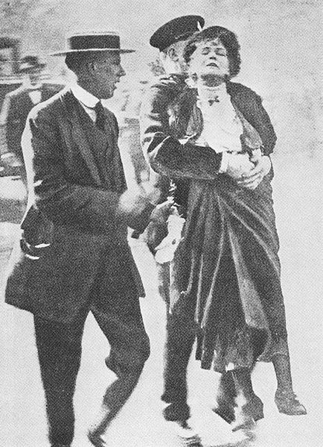
As the violence continued and the police stood by while suffragists were beaten by the mob, the public discussion shifted from the protests, which the press had characterized as near treason, to the suffragists’ dedication and strength. After all, as Alice Paul repeatedly pointed out, the banners were merely words on cloth while the violence was a threat to life and liberty.
A suffragist being arrested
The NWP did not restrict its activities to picketing the White House and the Capitol. It opposed the Democrats in the 1914 and 1916 elections but without much effect. Protesters would appear at events attended by the President outside of Washington. Wilson’s speeches extolling democracy were burned at NWP demonstrations to show the women’s disgust that Wilson refused to extend his stirring rhetoric to women. The NWP went so far as to burn the President in effigy. All of this occurred in time of war when Wilson’s popularity with the American people was very high.

Making Imprisonment and Torture an Argument for Suffrage
Five hundred suffragists were arrested for picketing and 168 were sentenced to terms in jail for the minor traffic offense of blocking the sidewalk. In court, the suffragists stood on their First Amendment “right of the people peacefully to assemble, and to petition the Government for a redress of grievances.” They also denied the authority of the court. At her trial, Alice Paul told the judge, "We do not consider ourselves subject to this Court since, as an unenfranchised class, we have nothing to do with the making of the laws which have put us in this position."
No jury trial was permitted for traffic charges. When convicted by the judge, the suffragists refused to pay their fines and the court sent them to jail for ever increasing lengths of time. When President Wilson sought to defuse the issue by pardoning some of the women, they protested that they had been guilty of no crime and wanted no pardon. Women who had served their sentences reappeared on the picket line shortly after their release and were arrested again.
When the group of picketers that included Alice Paul was arrested, the only evidence against them was the testimony of a police sergeant:
I made my way through the crowd that was surrounding them, and told the ladies they were violating the law by standing at the gates, and would not they please move on. . . . They did not, and they did not answer either … [I] placed them under arrest.

The women carrying banners, Alice Paul and another lady, were sentenced to seven months in prison. Two women who were simply standing on the picket line that day were given a choice between five dollar fines and 30 days in prison. They refused to pay the fines and were committed to jail.
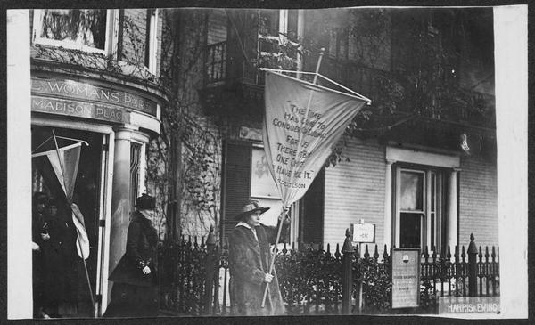
Alice Paul and others on their way to the White House
During the First World War, lack of tolerance for dissent was not applied only to suffragists. Almost 2,000 people were prosecuted under the newly passed Espionage Act; nearly all of the prosecutions arose from speeches, newspaper articles, leaflets and books expressing opposition to the war. Sentences for people prosecuted under the Espionage Act were often many years, not just a number of months.
The movie presents an accurate description what life was like for the suffragists in prison. They were housed with the usual prison population of prostitutes and criminals and received the same harsh treatment that was afforded at that time to convicted criminals. Spoiled food, harsh discipline, damp, unventilated cells with buckets instead of toilets, denial of medical care, and forced labor were the order of the day for women jailed for criminal offenses. Blankets were only washed once a year and the soap in the showers was used in common despite the fact that some prisoners suffered from tuberculosis and other communicable diseases. The suffragists were middle and upper class women. Neither they, nor American society, were used to women of this class being treated like common criminals.
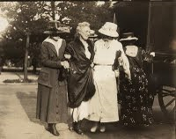
In many ways, the prison conditions were worse for the suffragists than for criminal offenders. Some suffragists were held incommunicado for weeks at a time with no visitors from the outside allowed. All of the arrested
A suffragist released from prison
women were white and at that time, usually, white and black convicts were housed in different areas of the prison. However, the suffragists were placed in the area that housed black women, a great affront in those times of rampant racial prejudice. The prisoners who had been convicted of crimes were forced by the guards to assault and humiliate the suffragists. Moreover, when the suffragists protested jail conditions or demanded special treatment as political prisoners, the authorities ramped up the pressure and conditions worsened. Suffragists were attacked by guards, Lucy Burns was hung up by her hands, and women complaining about the food or other prison conditions were placed in solitary confinement. When the suffragists went on hunger strikes in response, they were brutally force fed three times a day through a tube pushed into their stomach through their mouth or nose.
The worst treatment was reserved for Alice Paul. In addition to placing her in solitary confinement and subjecting her to brutal force feeding when she went on a hunger strike, the government tried to have Miss Paul committed indefinitely to a mental hospital for the insane. She was transferred to a cell in the psychopathic ward of the prison and her solitary confinement continued there. She had no privacy. Once an hour, day and night, a nurse flashed a light in her face making normal sleep impossible. Doctors visited the prisoner and told her that she was in an unstable mental condition.
As described in the movie, Alice Paul was saved from commitment as insane when the government’s chief psychiatrist, Dr. William A. White, demonstrated his professionalism by stating that she was emotionally healthy; she simply disagreed with Mr. Wilson. Dr. White later said that he when he examined Miss Paul, “I felt myself in the presence of an unusually gifted personality" and . . . "she was wonderfully alert and keen . . . possessed of an absolute conviction of her cause . . . with industry and courage sufficient to avail herself of [all diplomatic possibilities].”
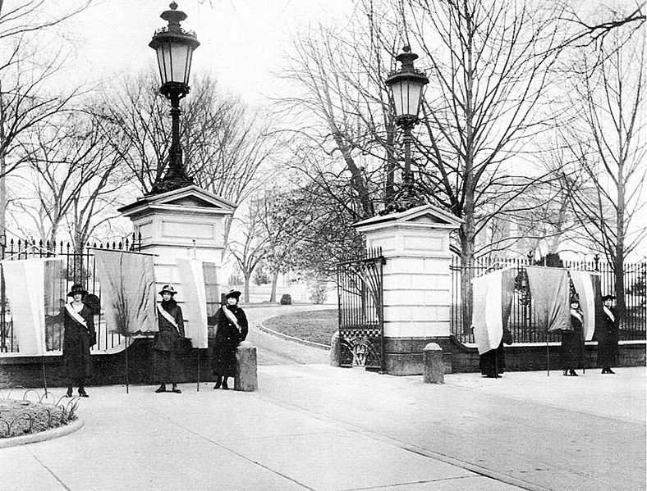
Through it all, Miss Paul and the other imprisoned women stood steadfast for their cause, communicating with the outside world and continuing the struggle through notes secretly carried by attorneys, friends, and sympathetic guards. Although President Wilson tried to instigate a press blackout on stories of prison conditions, the public outcry against the government for the way it treated the suffragists was enormous.
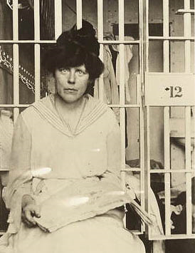
From January 1917, the NWP found ways to present its case to the American people on an almost daily basis. The government was unable to stop the picketing of the White House. When thrown into jail, their story could have ceased to exist. The public could have forgotten about them. But the NWP found ways to keep the story in the national media. Women who had been imprisoned made speeches and the NWP organized the “Prison Special”, a train in which formerly imprisoned suffragists toured the country. Stories about the
Lucy Burns in Prison – She served longer than any other protester
mistreatment of the suffragists brought shame to the government. Paul believed that if the pickets remained at the White House gates despite the weather, despite assaults by the crowds, and despite imprisonment in conditions amounting to torture, the government would have to give in. As Doris Stevens wrote in Jailed For Freedom:
I remember so well when the situation was approaching its final climax in Washington. Men and women, both, came to Miss Paul with, "This is terrible! Seven months' sentence is impossible. You must stop! You cannot keep this up!"

With an unmistakable note of triumph in her voice Miss Paul would answer, "Yes, it is terrible for us, but not nearly so terrible as for the government. The Administration has fired its heaviest gun. From now on we shall win and they will lose."

During this crucial period, NWP and NAWSA strongly criticized one another. The NWP took the position that NAWSA’s accommodating, slow, state by state campaign was not effective and would leave some women, particularly in the South, disenfranchised. NAWSA constantly took Paul and the NWP to task for taking a confrontational approach, claiming that by making politicians and many people angry for refusing to support the war effort and criticizing the President, the NWP had set back the cause. NAWSA, cooperating with the Wilson administration, did its best to undermine the NWP’s efforts. When the NWP asked women voters to refuse to support the Democratic Party candidates because it would not endorse the constitutional amendment, NAWSA asked women to ignore the NWP. When Miss Paul and the NWP were getting excellent press for their heroic resistance while in prison, NAWSA officials cooperated with President Wilson’s attempt at a news blackout and wrote to the newspapers urging them to stop making martyrs of the suffragist prisoners.
However, NAWSA and the suffrage cause received immense benefits from its cooperation with President Wilson and its opposition to the tactics of the NWP. The payback was President Wilson’s active support for suffrage in response to requests from NAWSA. An energized NAWSA, with Wilson’s support, obtained suffrage for women in New York in 1917. This was the first large Northeastern state to give the vote to women. In October, 1917, with NWP militants still regularly being arrested and Alice Paul still in jail, President Wilson changed his position and began supporting a constitutional amendment providing for women’s suffrage.
In late November, 1917, President ordered all the women unconditionally released without any explanation. The NWP continued to picket the White House and pressure the President to take positive steps to promote the constitutional amendment, until it was passed by Congress in June of 1919. While some arrests were still made, on occasion, the sentences were short and the conditions of imprisonment better.

1918 and 1919
On September 30, 1918, President Wilson gave an address to Congress, described in the movie, calling for women’s suffrage as a war measure and asking Congress to pass the suffrage Amendment. In that year, NAWSA campaigns secured women’s suffrage in Michigan, Texas, South Dakota and Oklahoma, for a total of 17 suffrage states. Other states passed partial women’s suffrage. With more and more senators and representatives coming from suffrage states, the new Congress supported women’s suffrage by a wide margin. In 1919, with eight more states having passed suffrage initiatives or about to do so, the women’s suffrage amendment came up for a vote again. The suffrage amendment was passed by the House on May 21, 1919 and by the Senate in June.
The next task was to win ratification votes in the legislatures of 36 states. Many states quickly ratified the 19th Amendment, aiming to be the first to do so. NAWSA and the NWP sent lobbyists all over the country to secure ratification from as many states as possible. President Wilson provided political firepower whenever NAWSA asked. As shown in the movie, Tennessee provided the last ratification needed for the 19th Amendment.

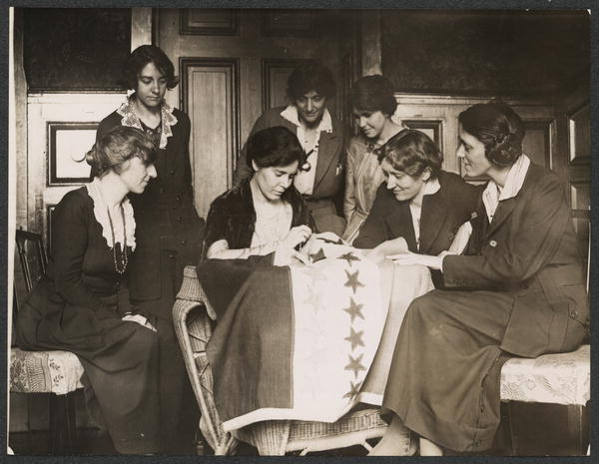

Ever mindful of the visual image, Alice Paul sews a star on the suffrage
flag representing another state that had ratified the 19th Amendment.

On August 27, 1920, the day the Secretary of State signed the proclamation that the 19th Amendment had been adopted, President Wilson said:
. . . I deem it one of the greatest honors of my life that this great event, the ratification of this amendment, should have occurred during the period of my administration.
. . . [N]othing has given me more pleasure than the privilege that has been mine to do what I could to advance the cause of ratification, and to hasten the day when the womanhood of America would be recognized by the nation on the equal footing of citizenship that it deserves.'"

Conclusion: Alice Paul and the Suffragist Movement in Historical Perspective
On the whole, it appears that Mrs. Catt’s “Winning Plan”, which developed a critical mass of states that that had enacted women’s suffrage, and her decision to put President Wilson in her political debt by abandoning her pacifism and leading NAWSA to support the war were the most important ingredients of success in securing passage of the 19th Amendment. However, Alice Paul’s nonviolent militant approach: (1) kept the push of political pressure on the President, (2) kept the suffrage issue before the voters, (3) vividly made the point that the U.S. was being hypocritical in fighting a war to make the world safe for democracy while denying the vote to millions of women, and (4) earned the respect of the nation by standing steadfast despite false arrests, wrongful imprisonment, and torture by the government, was also an important ingredient in the overall suffrage victory. No one knows whether the suffrage movement would have been victorious in 1920 without Alice Paul and the militants of the NWP. While historians can argue about whether the NAWSA or the NWP approach was the more influential in securing the vote for women, looking at the suffrage movement as a whole, it is clear that Mrs. Catt and NAWSA along with Miss Paul and the NWP, the first leading the President with a gentle accommodating hand, and the second pushing the President along with hostile nonviolent demonstrations and protests, pursued what amounted to a brilliant, if an unintended strategy.
During the 20th century, there were four great expansions of human rights in the United States: women’s suffrage, civil rights for blacks and minorities, increased procedural rights for persons accused of crimes, and civil rights for the disabled. Women’s suffrage and civil rights for minorities were the reforms that improved the lives of the greatest number of people and required the largest changes in attitude on the part of American society. They both employed the techniques of nonviolent mass action and prevailed despite violent repression.
It can only be hoped that in the next great crisis, leaders such as Miss Paul and Mrs. Catt will appear and help the American people find their way. Given the experience of the 20th century, it would not be surprising if nonviolent mass action turns out to be one of the basic tools in any future movement for reform.

Epilogue – Catt and Paul After the 19th Amendment
After the 19th Amendment was ratified, most suffragists left activism and returned to their traditional lives with their families. Lucy Burns, for example, retired from the public arena, devoting herself to the Catholic Church and to raising an orphaned niece. There were many, however, who didn’t rest. Carrie Chapman Catt founded the League of Women Voters, which focused on educating women so that they could effectively exercise their new right. The League is still active and describes itself as a “nonpartisan political organization [that] encourages informed and active participation in government, works to increase understanding of major public policy issues, and influences public policy through education and advocacy”.
Alice Paul and the NWP took a different path, focusing on a new constitutional amendment requiring equal rights for women. Alice Paul wrote both versions of the Equal Rights Amendment that have been submitted to Congress. The second version of the ERA states, simply, that:
Equality of rights under the law shall not be denied or abridged by the United States or by any state on account of sex.

This version of the ERA was adopted by Congress in 1972 but fell three states short of ratification, due to the increasingly conservative turn taken by the United States after 1970. Alice Paul died in 1977 thinking that the ERA would soon be ratified and not knowing of the eventual frustration of her efforts.
James Frieden, TeachWithMovies.com, January, 2010

Bibliography: See Learning Guide to “Iron Jawed Angels”

Alice Paul had the right to be referred to as “Dr. Paul” by virtue of having been granted a PhD. However, it doesn’t appear that she favored this title. She is referred to as Miss Paul in this article because the term “Ms.” was not used in the early 1900s and to stress the fact that she was very young.
Persons who are accused of crimes and are found to be insane are committed to mental hospitals until they are well. The commitment can last far longer than the sentence for the crime of which the prisoner is accused. The threat of committing a woman was especially menacing. In the late 1800s, women who objected to the conditions in their lives and were unwilling to live by the strict conventions of society were sometimes classified as insane and incarcerated in mental hospitals. This was still a real fear in the early 20th century for a “difficult” woman such as Alice Paul.
On March 14, 1918, the District of Columbia Court of Appeal ruled that each of the women had been “illegally arrested, illegally convicted, and illegally imprisoned.”?
Rights for the handicapped were established by legislative action with the passage of the Americans With Disabilities Act in 1990. Rights for persons accused of crimes were enhanced by court decisions and legislation.
Domesticating Drink – Women, Men and Alcohol in America, 1870 – 1940 pp. 27 - 31
Wyoming (1869), Colorado (1893), Utal (1896), Idaho (1896), Washington State (1910), California (1911) Oregon (1912), Kansas (1912), and Arizona (1912),
The Elizabeth Cady Stanton and Susan B. Anthony Papers Project at Rutgers University. http://ecssba.rutgers.edu/docs/sbatrial.html accessed December 24, 2009.
Frederick Douglass, from the Western New York Suffragists Web Site, http://www.winningthevote.org/FDouglass.html accessed December 20, 2009.
They were Wyoming (1869 as a territory, becoming the first state with women’s suffrage in 1890). , Colorado (1893), Utah (1895), Idaho (1896); Washington State (1910), California (1911), Michigan (1912), Kansas (1912), Oregon (1912), Arizona (1912).
See, e.g., Lunardini and Adams and Keane, For contemporary observers, see, generally, Stevens, 1920, and in particular the passage citing telegram from Walter Clark, Chief Justice of the Supreme Court of North Carolina, p. 18. For the opinions of two women who were active in the suffrage movement but not in Paul's National Women's Party, see Gluck, 1976, Interview of Jessie Haver Butler, p. 105 and Laura Ellsworth Seiler, p. 228. These interviews are also available on TeachWithMovies.com and are linked in the Learning Guide to the movie, Iron Jawed Angels.
Fox, George (Faith and Practice 7; This paragraph derived from Adams & Keane, 3.
Adams and Keane 4
Adams and Keane 20
Adams and Keene 1, 6, 7, 19 & 20
Adams and Keene 24
Adams and Keene 99
Adams and Keane 11 & 12 and 76 - 92
Adams and Keane 101
Adams and Keane 173
Stevens 11 - 17.
Adams and Keane 157 - 167
Adams and Keane 162 & 163
Adams and Keane 163
Adams and Keane 167 – 172.
Adams and Keene 32
Lunardini 128
Adams and Keane 177, 178, 185 & 186
Adams and Keane 186 - 189
Adams and Kean 190
The Trials of Alice Paul and Other National Woman's Party Members: 1917 - Suggestions For Further Reading http://law.jrank.org/pages/2806/Trials-Alice-Paul-Other-National-Woman-s-Party-Members-1917.html accessed on January 1, 2009
Adams and Keane 178 & 179
Adams and Keane 184
Adams and Kean 178, 179, 182, 183& 186
Ibid.
Adams and Keane 180
Stevens 196 – 220; and Adams and Keane 191 – 214
Adams and Keane 203
Stevens 217 & 218; 220- 222, 226; Adams and Keane 203 & 204, The quote is at Stevens, p. 226.
Bozonelis 48 – 55; Lunardini 129-136, 138; Baker 217 - 220
Stevens 17.
Lunardini 83, 84, 123, 124; 128, 163; NAWSA never criticized the denial of civil rights to arrested NWP picketers. Lunardini 138;
Adams and Keane 210;
Lunardini, 141.
Adams and Keane 212
Lunardini 143 – 156, Adams and Keane, 216 - 218
http://en.wikipedia.org/wiki/Nineteenth_Amendment_to_the_United_States_Constitution#cite_note-1
Adams and Keene 243, 244
Adams and Keene 245
Colby Proclaims Woman Suffrage; New York Times, August 27, 1920, pg. 1. Available at http://www.nytimes.com/learning/general/onthisday/big/0826.html#top accessed December 25, 2009.
League of Women Voters Web Site – About Us -- http://www.lwv.org/AM/Template.cfm?Section=About_Us accessed December 25, 2009.
Baker, 227 & 228; Alice Paul:Feminist, Suffragist and Political Strategist - from the Alice Paul Foundation online pdf document accessed December 20, 2009.

